CONFIDENTIAL AND PROPRIETARY

Aries Systems Corporation



Product Functional Specification

13.0-33v4

Assign Author

Status: Ready for Management approval

Copyright © 2015, Aries Systems Corporation

This document is the confidential and proprietary property of Aries Systems Corporation. The contents hereof are for use only by recipients specifically identified by Aries, and may not be further disclosed to any other third party. Specifications, designs and drawings contained herein are subject to withdrawal or change by Aries, without notice. Aries shall have no liability resulting from such withdrawal or change. Editorial Manager is a registered trademark and the property of Aries Systems Corporation.

Aries Systems reserves the right to share this specification with other individuals or organizations that have entered into confidentiality agreements with Aries Systems, in which case the specification will be appropriately blinded so that no identifying or proprietary information will be exposed.

Document Summary

Enhancement Name | Assign Author
Specification Number | 13.0-33
Enhancement Type | LWW
Implemented In | 13.1

Document Revision History

Date | Author | Comments
11/02/15 | Di Natale | V0 - Initial draft started
12/21/15 | Di Natale | V1 – Ready for internal review
12/30/15 | Di Natale | V2 – Revisions based on feedback from CW, SU, LC, JS – adds named ‘Un-assign’ link, extends ‘Un-assigned’ link to accepted invitations, adds Author statuses for use on Author Selection Summary page, clarifies connection to Alternate Authors, clarifies that assigned Authors do not trigger Alternate promotions when unassigned, updated ActionManager events, Added Authors to Assign grid to Select Authors – Confirm Selection and Send Letters page
2/09/16 | Di Natale | V3 – Updating based on SM feedback, added new ActionManager event, new statuses on Author Selection Summary page, clarifications around new un-assign link, added test cases
2/12/16 | Di Natale | Ready for Management approval

Specification Approvals
Department | Date | Version | Name
Corporate | 2/17/16 | 4 | LH
Product Mgt.
Engineering | 2/16/16 | 4 | BM
Operations
Customer Service
Aries KG
Sales | 2/16/16 | 4 | RW
Table of Contents

1 Overview 4
1.1 Glossary 6
1.2 Related Specifications 6
2 Application Impact 7
2.1 Editor Role Definition page [roleMgrEditor2.asp] 7
2.2 ActionManager [admin/eventGrid.asp] 9
2.3 Author Selection Summary page [authorSelectionSummary.aspx] 13
2.4 Un-invite Author page [confirmAndCustomizeUninvitedAuthors.aspx] 22
2.5 Un-invite E-Mail Confirmation page [sendMultipleCustomAuthorInvLetters.asp] 27
2.6 Search for Authors by Name Results page [searchAuthorsByNameAddrResults.asp] 29
2.7 Search for Authors by Personal Classifications Results page [searchAuthorsByPersonalClassResults.asp] 35
2.8 Upload Author List page [uploadAuthorList.aspx] 39
2.9 ‘Author Candidates’ Results page [UploadedAuthorSearchResults.aspx] 41
2.9.1 Author List File interaction with ‘Author Candidates’ Results page 44
2.10 Select Authors – Confirm Selection and Customize Letters page [confirmAndCustomizeInvitedAuthors.aspx] 47
2.10.1 Database tracking of assigned Authors 54
2.11 Author Invitation Confirmation page [sendMultipleCustomAuthorInvLetters.asp] 54
2.12 Author Main Menu [AuthorMainMenu.aspx] 57
2.13 My Accepted Invitations [authorAcceptedInvitations.asp] 58
2.14 Author Statistics 62
3 Database Impact 67
3.1 DB Content Changes 67
3.2 UDB Impact 67
4 Multi-Lingual Considerations 67
5 Performance Processing Impact 67
5.1 Performance Requirements 68
5.1.1 Data Server 68
5.1.2 Web Server 68
5.1.3 Network 68
5.1.4 Client Machine 68
5.2 Engineering Assessment 68
5.2.1 Engineering Test Results 68
6 Merge Field Impact 68
7 Upgrade Script Impact 68
8 Site Cleanout 68
9 Report Implications 68
9.1 Canned Reports 69
9.1.1 Co-Author Reminder Report 69
9.1.2 Author Revision Status Report 69
9.1.3 Author Revision Reminder Report 69
9.1.4 Automated Author Revision Reminder Report 69
9.1.5 Automated Author Transfer Reminder Report 69
9.1.6 Proposal Pipeline Report 69
9.1.7 Authors Invited – No Response 69
9.1.8 Author Invitation Status Report 70
9.2 General Data Export 70
9.3 Custom Reports 70
9.4 Enterprise Analytics Reporting 71
9.5 Cross-Publication EAR 72
10 Hosting Documentation Impact 72
11 Portal (IJRS, etc.) Impact 72
12 Hosting Administration Impact 72
12.1 Hosting Administration Audit Trail 72
13 Sys Admin Audit Trail 72
14 Import/Export Impact 72
14.1 Transmittal Impact 72
14.2 Aries Export Impact 73
14.3 Aries Import Impact 73
15 Transfer Impact 73
16 Cross-Publication Impact 73
17 Documentation and Training 73
18 Operations’ Considerations 73
18.1 Journal Rename 73
18.2 Journal Redirects 73
19 Utilities 73
20 Audit/Monitor/Diagnostics 73
21 Journal Configuration 73
22 Style Sheet impact 74
23 Deployment Considerations 74
23.1 Associated Revenue Model 74
23.2 Sales and Marketing Rollout Anticipation 74
23.3 Customer Service Rollout Preparation 74
23.4 Release Target 74
24 Future Development 74
25 Mobile Considerations 74
26 Use Cases and Test Scenarios 75
26.1 Regression Test Cases 75
26.2 Specification Test Cases 75
27 Appendix A: Technical Specification 97

Overview
In Editorial Manager a publication can invite Authors to submit manuscripts in order to solicit submissions through the system. Today these solicitations require that the potential Author accept an invitation before the submission process can begin. The sponsoring customer will be using EM to manage a books workflow where Authors are generally contacted in advance, outside the submission system, and have already agreed to submit during that communication. For this reason, the option to assign Authors directly has been requested by the sponsoring customer and is preferable to requiring an invitation to be accepted through the interface when an Author has already agreed to provide a particular piece of content or an arrangement has otherwise already been reached.

An ‘Assign Author’ option will be added to Editorial Manager in order to better support books workflows where communication with the Author has started before EM is necessary and other invited workflows that call for a direct assignment. This new functionality will be supported through the traditional ‘Search Author’ functionality as well as within the selection of Authors via an uploaded Author List File (ALF) as introduced in EM version 13.0.

The ability to assign Authors will be granted to Editors through a new RoleManager permission which will be added in addition to the existing ‘Invite Authors’ permissions. Editors with both permissions would be able to choose whether or not to assign or invite an individual Author. The selection options configured for an Editor would be available when viewing Author search results – similar to the behaviour of the Invite/Assign Reviewer options in Reviewer Search Results. Once made, assignments would display to the Author initially on the Author Main Menu in the My Accepted Invitations folder.

When selecting Authors under this new functionality Editors will be able to assign only, invite only, or choose between both options when selecting authors, depending on the configuration of their permissions. The Author Selection Summary page will be enhanced to accommodate the new options. In current functionality invited Authors can be uninvited at any point up to the initial submission of their manuscript using an available ‘Un-invite’ link. While it will continue to be possible to remove Authors the label of the links and the ActionManager event it triggers will be adjusted to support the new concept of Author assignment.
- Existing functionality
  - The Un-Invite link appears and persists even after submission is in progress.
  - Un-inviting an Author automatically promotes the Alternate Authors when configured to do so
- New functionality
  - The Un-Invite link will now appear only up to the point of Acceptance.
  - An Un-Assign link will now appear after the point of Acceptance for an Invited Author; and right away for an Assigned Author (i.e. an Assigned Author is the same state as an Invited Author who accepts)
    - Thus, the concept of unassigning is introduced, applying to active/in-progress author invitations and the new assignments
- Unassigning an Author behaves differently for invited/accepted and assigned Authors
  - For invited/accepted Authors the promotion of Alternate Authors is triggered per the Article Type’s configuration and selection of Alternate Authors
    - This is the same behavior currently in place when an invited/accepted Author is uninvited
  - For assigned Authors, no Alternate Author is promoted
    - Authors who are assigned will never trigger alternates when unassigned

To account for the new ability to assign Authors, the ‘Author Candidates’ grid is enhanced to provide separate options for ‘Invite’ and ‘Assign’ in place of the existing ‘Select’ option, modeled after the existing ‘Reviewer Candidates’ grid. The ‘Select As’ column will be divided up with separate columns, added for inviting and assigning Authors, with checkboxes for each of the new options. The new columns will appear only to Editors with permission to use their given function. To account for the new direct assignment option the ‘Number of Invitation Letters’ column will be renamed ‘Number of Letters’ while remaining functionally the same so that an Author may receive multiple solicitations at the same time.

In addition to enhancements to the Author searching and selection pages in the interface, processing of an Author List File (ALF) will be enhanced, changing how the existing INVITE column values are interpreted so that Authors can be selected for assignment or invitation when selected via the uploaded file. No new columns will be needed in order to allow Authors included in the uploaded list to be initially selected for assignment or invitation. Once an ALF is loaded, both options will always be available when selecting Authors on the ‘Author Candidates’ Resultspage regardless of an Editor’s RoleManager configuration so that the selections made based on the uploaded file are always visible and adjustable by an Editor. This also ensures that the ALF import process does not ignore or discard correctly formatted data included in the file.

Engineering will determine how to store Author assignment records, however using the Invited Authors Table, modified to contain a column clarifying whether the record was an invitation or assignment, is suggested in order to keep Author data conveniently located for reporting purposes and to lessen the impact on existing pages which will need to display assignment data (similar to the reviewer invitation/assignment functionality). This is the table used currently to store data about pending and accepted invitations. It is the intention of this specification to as closely as possible treat Author assignment records in the same way that accepted Author invitation records are treated by the system under existing functionality.

Glossary
Solicited Workflow – For all intents and purposes this is an invited workflow where Editors solicit Authors for submissions. This includes invitation and assignment of Authors via a Proposal or as a Solicited Commentary. Both Proposals and Commentaries workflows support the use of an Author List File for the selection of Authors.

Contributor – A term for Authors specific to the envisioned books workflow this specification will support

Author List File (ALF) – An external file to EM which contains a list of Authors and other metadata which can be uploaded into EM in order to allow individuals listed in the file to be selected.

Invited/accepted Author – An Author who were invited and then accepted the invitation to submit a solicited work through Editorial Manager. While this case can exist for Authors in EM today, removing these Authors will trigger new ActionManager events detailed in this specification

Assigned Author – An Author who were directly assigned without invitation to submit a solicited work through Editorial Manager.

Related Specifications
3.0-01 Proposals and Commentaries: Initiating and Managing Proposals and Commentaries – Introduces the invited workflow functionality for Proposals and Solicit Commentary.

6.0-06 Proposal Improvements – Modified the existing Proposal functionality, establishing the features and UI which exist today

7.0-28 Initiate Proposal Enhancements – This specification created the preselected Article Type settings used by Editors to control the Article Type of submissions coming into EM via invitations. This differs from the predefined title values functionality introduced by this specification because preselected Article Types apply to all of the invitations sent from a Proposal. The predefined title values will be tied to each individual invitation instead.

9.0-53 Assign Reviewers – Added an assignment option for reviewers which allowed them to be directly assigned rather than having to accept an invitation to review. Much of the implementation of the new functionality which enables Author assignment follows 9.0-53 as a guide for how to present the selection options and treat the resulting assignment record.

10.0-62 Cross Portal Author and Reviewer Invitation Statics Display – Introduced the display of cross-publication Author statistics for publications sharing people information via EM Portal (IJRS). Fields updated by the assignment of an Author are shared cross-publication.

13.0-12 Automated Reminders for Invited Authors – Specification creates automated reminders for invited Authors.

13.0-18 Upload Author List – Introduces the ability to upload a list of Authors using an Author List File (ALF) in order to select them for invitation.

13.0-31 Predefine Invited Submission Article Titles – Enhances the Author invitation process in order to allow Editors to predefine title values while inviting Authors to submit via Proposal or Solicited Commentary.

Application Impact
- Editor Role Definition page [roleMgrEditor2.asp]
- ActionManager [admin/eventGrid.asp]
- Author Selection Summary page [authorSelectionSummary.aspx]
- Un-invite Author page [confirmAndCustomizeUninvitedAuthors.aspx]
- Un-invite E-Mail Confirmation page [sendMultipleCustomAuthorInvLetters.asp]
- Search for Authors by Name Results page [searchAuthorsByNameAddrResults.asp]
- Search for Authors by Personal Classifications Results page [searchAuthorsByPersonalClassResults.asp]
- Upload Author List page [uploadAuthorList.aspx]
- ‘Author Candidates’ Results page [UploadedAuthorSearchResults.aspx]
- Select Authors – Confirm Selection and Customize Letters page [confirmAndCustomizeInvitedAuthors.aspx]
- Author Invitation Confirmation page [sendMultipleCustomAuthorInvLetters.asp]
- Author Main Menu [AuthorMainMenu.aspx]
- My Accepted Invitations [authorAcceptedInvitations.asp]

Editor Role Definition page [roleMgrEditor2.asp]
The Editor Role Definition page [roleMgrEditor2.asp], where RoleManager permissions are set for existing and new Editor Roles, is enhanced by this specification with a new permission for Editors.

A new ‘Assign Authors (without Invitation)’ permission is added to the existing Proposals/Commentaries section of RoleManager. When enabled, the new permission allows Editors to access the Author Selection Summary page from the same access points available to users with the ‘Invite Authors/Solicit Commentaries permission in the current functionality and then select Authors for assignment when viewing Author search results. Additionally, Editors will be able to unassign any Authors who have not yet submitted after being assigned and uninvite invited Authors who have not yet accepted– in the same manner that the existing ‘Invite Authors/Solicit Commentaries’ allows Authors to be uninvited – on the Author Selection Summary page.

The new permission is not directly tied to the existing permissions for inviting Authors or selecting Alternate Authors as assignments will occur independent of those existing methods. The intention is to allow two separate selection workflows which are not depended on each other. Editors will not need permission to invite Authors to be able to assign them. The Assignment functionality will not be extended to Alternate Author selection by this specification; Alternate Authors will not be selectable for Authors who are being assigned. Additionally, unassigning Authors selected via assignment will not trigger the promotion of alternates associated with the parent submission. NOTE: Invited Authors who have accepted will continue to trigger the promotion of alternates when removed, as is the case in current functionality.

Figure 1: Mocked up Editor RoleManager configurations showing new ‘Assign Authors (without Invitation)’ permission.
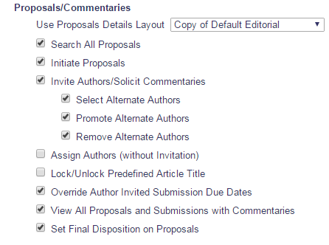

- The ‘Assign Authors (without Invitation)’ permission is added to RoleManager for Editor Roles
  - The new permission is added to the ‘Proposals/Commentaries’ section of the Editor Role Definition page
  - The permission is placed above the ‘Lock/Unlock Predefined Article Title’ permission (which is added in EM 13.1 by Spec 13.0-31) and following the existing ‘Invite Authors/Solicit Commentaries’ permissions and its related sub-permissions.
  - This permission will NOT be enabled by default for any Editor Role at upgrade
- Administrators will be able to select the new permission independently of the existing ‘Invite Authors/Solicit Commentaries’ permission
- Enabling this permission for an Editor Role provides access the new Author assignment functionality on the Author Selection Summary page (Section 2.3) and the subsequent results and confirmation pages detailed later in this specification

ActionManager [admin/eventGrid.asp]
This specification creates four new ActionManager events, ‘Author Assigned (Not Invited) for Proposal’, ‘Author Assigned (Not Invited) for Commentary’, ‘Author Unassigned after Accepting Invitation’, and ‘Author Unassigned after Assignment’. These events will be used when an Author is assigned by an Editor with the new ‘Assign Authors (without Invitation)’ permission and when an assigned Author is removed in order to send notification letters as part of the new Author assignment process. As is the case for the existing ActionManager events for invited workflow, these new events trigger letters to users tied to the parent submission/Proposal which is being used to create the assignments.

- A new ‘Author Assigned (Not Invited) for Proposals’ event is added to the ‘Author Invitation’ section of the ActionManager role configuration page
  - It is displayed following the existing ‘Invite Authors for Proposal’ event
  - The new event is triggered when an Author is assigned via a Proposal by an Editor using the new Author assignment functionality introduced by this specification
  - At upgrade, no letter is configured for the event for any role
    - As with existing ActionManager events, administrators can select a letter from any letter family other than ‘Ad hoc from Author’, ‘Ad Hoc from Reviewer’ , ‘Ad Hoc from Editor’, ‘Ad Hoc from Publisher’, and ‘Ad Hoc for Proposal’
  - If configured for the Author Role, the letter template associated with the event will be the default option on the Select Authors – Confirm Selections and Customize Letters page (See Section 2.10) for each Author being assigned
  - A letter can be configured to be sent to Editors associated with the parent submission/Proposal which is being used to generate the assignment when a letter template is associated with the new ‘Author Assigned (Not Invited)’ event for their Editor Role
    - The configured letter would be sent to the lowest Editor in the chain who has not made a decision (Handling Editor) and to the “special relationship Editor” (Editor who assigned the first Editor)
    - Note: These are the same possible Editor recipients for the existing ‘Author Agrees to Invitation’ and ‘Author Invited for Proposal’ events
  - The Document Status for the new event is configurable
    - The default value is set to “No Change” at upgrade for existing roles and at creation for new roles
      - If a change of status occurred it would impact the parent submission/Proposal
    - This is modeled after the existing ‘Invite Authors for Proposal’ event
    - There is no default Alternate Text for Authors for this event
- A new ‘Author Assigned (Not Invited) for Commentary’ event is added to the ‘Author Invitation’ section of the ActionManager role configuration page
  - It is displayed following the existing ‘Solicit Commentary on Submission’ event
  - The new event is triggered when an Author is assigned via the Solicit Commentary process (used when the parent submission is not a Proposal) by an Editor using the new Author assignment functionality introduced by this specification
  - At upgrade, no letter is configured for the event for any role
    - As with other ActionManager events, administrators can select a letter from any letter family other than ‘Ad hoc from Author’, ‘Ad Hoc from Reviewer’ , ‘Ad Hoc from Editor’, ‘Ad Hoc from Publisher’, and ‘Ad Hoc for Proposal’
  - If configured for the Author Role, the letter template associated with the event will be the default option on the Select Authors – Confirm Selections and Customize Letters page (See Section 2.10) for each Author being assigned
  - A letter can be configured to be sent to Editors associated with the parent submission/Proposal which is being used to generate the assignment when a letter template is associated with the new ‘Author Assigned (Not Invited)’ event
    - The configured letter would be sent to the lowest Editor in the chain who has not made a decision (Handling Editor) and to the “special relationship Editor” (Editor who assigned the first Editor)
    - Note: These are the same possible Editor recipients for the existing ‘Author Agrees to Invitation’ and ‘Author Invited for Proposal’ events
  - Document Status for the new event is set to “No Change” and cannot be altered
    - This is modeled after the existing ‘Solicit Commentary on Submission’ event
      - Changing the status of the parent submission when soliciting a commentary is not desirable behavior
    - There is no default Alternate Text for Authors for this event
- A new ‘Author Unassigned after Accepting Invitation’ event is added to the ‘Author Invitation’ section
  - It is displayed following the existing ‘Un-invite Authors’ event
  - The new event is triggered when an assigned Author is removed by an Editor using the new Author assignment functionality introduced by this specification
    - This event is not triggered when an Author selected via assignment is unassigned
  - At upgrade, no letter is configured for the event for any role
    - As with other ActionManager events, administrators can select a letter from any letter family other than ‘Ad hoc from Author’, ‘Ad Hoc from Reviewer’ , ‘Ad Hoc from Editor’, ‘Ad Hoc from Publisher’, and ‘Ad Hoc for Proposal’
  - If configured for the Author Role, the letter template associated with the event will be the default option on the existing Un-Invite Author page for each Author being unassigned (See Section 2.4)
  - A letter can be configured to be sent to Editors associated with the parent submission/Proposal which is being used to generate the assignment when a letter template is associated with the new ‘Author Unassigned after Accepting Invitation’ event
    - The configured letter would be sent to the lowest Editor in the chain who has not made a decision (Handling Editor) and to the “special relationship Editor” (Editor who assigned the first Editor)
    - Note: These are the same possible Editor recipients for the existing ‘Un-invite Authors’ event
  - The Document Status for the new event is set to “No Change” and cannot be altered
    - This is modeled after the existing ‘Un-invite Authors’ event
      - Changing the status of the parent submission when un-assigning an Author is not desirable behavior
    - There is no default Alternate Text for Authors for this event
- A new ‘Author Unassigned after Assignment’ event is added to the ‘Author Invitation’ section
  - It is displayed following the new ‘Unassign Author after Accepting Invitation’ event
  - The new event is triggered when an assigned Author is removed by an Editor using the new Author assignment functionality introduced by this specification
    - This event is not triggered when an invited Author who has accepted the invitation is unassigned
  - At upgrade, no letter is configured for the event for any role
    - As with other ActionManager events, administrators can select a letter from any letter family other than ‘Ad hoc from Author’, ‘Ad Hoc from Reviewer’ , ‘Ad Hoc from Editor’, ‘Ad Hoc from Publisher’, and ‘Ad Hoc for Proposal’
  - If configured for the Author Role, the letter template associated with the event will be the default option on the existing Un-Invite Author page for each Author being unassigned (See Section 2.4)
  - A letter can be configured to be sent to Editors associated with the parent submission/Proposal which is being used to generate the assignment when a letter template is associated with the new ‘Author Unassigned after Assignment’ event
    - The configured letter would be sent to the lowest Editor in the chain who has not made a decision (Handling Editor) and to the “special relationship Editor” (Editor who assigned the first Editor)
    - Note: These are the same possible Editor recipients for the existing ‘Author Agrees to Invitation’ and ‘Author Invited for Proposal’ events
  - The Document Status for the new event is set to “No Change” and cannot be altered
    - This is modeled after the existing ‘Un-invite Authors’ event
      - Changing the status of the parent submission when un-assigning an Author is not desirable behavior
    - There is no default Alternate Text for Authors for this event

Figure 2: Mocked up ActionManager Role configuration page showing the new ‘Author Assigned (Not Invited) for Proposal’, ‘Author Assigned (Not Invited) for Commentary’, ‘Author Unassigned after Accepting Invitation’ and ‘Author Unassigned after Assignment’ events. The new events are highlighted, but not to be coded, in pink.
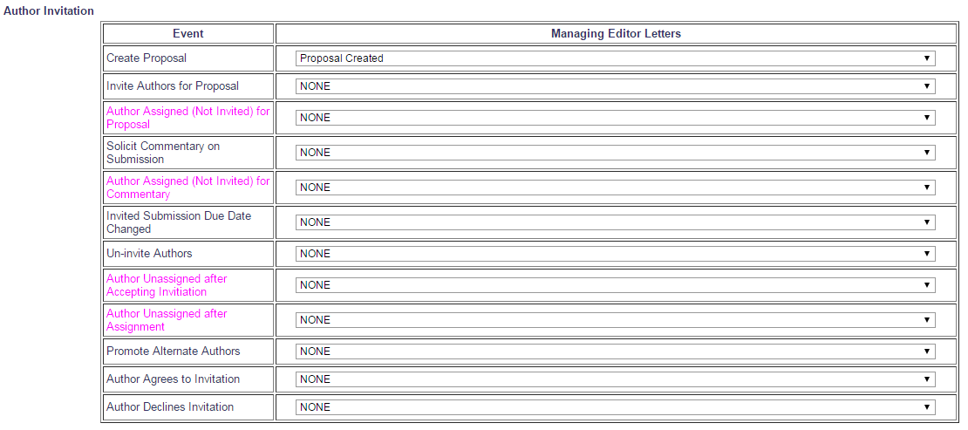

Figure 3: Mocked up ActionManager Document Status configuration page showing the new events. The new events are highlighted, but not to be coded, in pink.
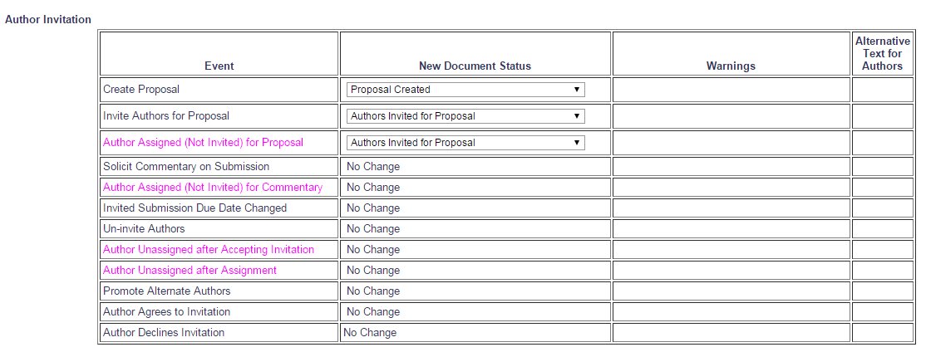

Author Selection Summary page [authorSelectionSummary.aspx]

The Author Selection Summary page [authorsSelectionSummary.aspx] is reached when clicking the Invite Authors Action Link in order to invite Authors using an existing Proposal, clicking the [Assign to Myself and Invite Authors] button when initiating a Proposal, or clicking the Solicit Commentary Action Link for a Regular Submission in order to solicit a commentary. Editors use this page to choose how they will select Authors (search or upload a list of Authors) for use in a solicited workflow and to review any pending invitations. Editors configured with the new ‘Assign Authors (without Invitation)’ permission will be able to access the page using these existing links in the same manner they can today when given the ‘Invite Authors/Solicit Commentaries’ permission.

The Author Selection Summary page is enhanced to support the ability to assign Authors and display them in the ‘Selected Authors’ section of the page. The tool tip displayed on this page when an Editor chooses to upload an Author List File (ALF) to select Authors is updated. This update reflects changes to how the INVITE column of ALF is interpreted by the system in order to facilitate both Author assignment and invitation. See Section 2.9.1 for details about changes to the processing of an ALF.

The existing UI and functionality will be used to display and manage assigned Authors, similar to the implementation of the Reviewer assignment functionality (Spec 9.0-53) where the existing layout and status terms continued to be used for the assigned Reviewers being displayed on the Reviewer Selection Summary page. In the ‘Selected Authors’ grid on the Author Selection Summary page, the assigned Authors are co-mingled in the Invited Authors grid with invited Authors when a mix of selection methods is used. Assigned Authors will initially be marked with the same ‘Agreed to Submit’ status as invited Authors who have accepted invitations.

Within the ‘Selected Authors’ grid the existing ‘Un-invite’ links will be enhanced and relabeled when appropriate based on the state of the solicitation. Currently, ‘Un-invite’ links appear next to Authors who have pending invitations and accepted invitations. Under the new functionality, the links will continue to be labeled ‘Un-invite’ while an invitation is pending, however, once an invitation is accepted, or if an Author was selected via the newly available assignment option, the link will be labeled ‘Un-assign’. Editors with either the new ‘Assign Authors (without Invitation)’ permission or the existing ‘Invite Authors/Solicit Commentaries’ permission will be able to view and use the ‘Un-invite’ and the new ‘Un-assign’ links when available. Using the ‘Un-assign’ link either for invited/accepted Authors or assigned Authors will trigger the new related ActionManager events, allowing journals to have default templates that vary when unassigning Authors based on whether they were initially invited or assigned.

Figure 4: Example of information icon as it appears on the Author Selection Summary page today.
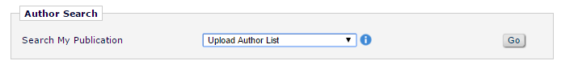

New Functionality:
- The existing Upload Author List tool tip is enhanced
  - The existing text launched from the information icon is updated to reflect the new functionality
  - Per existing functionality, when the ‘Upload Author List’ option is selected in the Author Search drop-down menu an icon is placed to the right of the drop menu
    - Per existing functionality, hovering over the icon with the mouse cursor produces a tool tip
    - Per existing functionality, the tool tip box can be expanded and collapsed by a user and initially appears in its collapsed form
      - The text of the collapsed version is not modified by this specification
    - The text of the expanded box is enhanced
    - The enhanced text of expanded tool tip, new text highlighted in pink:

Use this option to upload a list of potential Authors from a file which includes their First Name, Last Name, Email Address, and optionally, a description of the material they will be asked to author and an ORCID iD.

To upload a file of people to invite as Authors, you can either click the 'Choose File' button to browse your computer, or drag and drop a file onto the folder image below. Only a single file may be selected at a time.

Caution: The file must be in one of the following formats:
- Comma Separated Value (*.csv, *.txt)
- Tab Delimited File (*.tab, *.txt)

The first row must be a header with three to seven columns:
Required:
- FIRSTNAME
- LASTNAME
- EMAIL
Optional:
- INVITE
- TITLE
- NOTE
- ORCID

Information for each potential Author should be entered on a separate row. Each row included represents a separate invitation and Authors receiving multiple invitations appear in multiple rows. You may enter multiple email addresses separated by semi-colons.

INVITE is a true/false field which will determine how an Author is selected by default when the list is imported. When set to TRUE an Author is selected for invitation, when FALSE for assignment, and if no value is provided no selection is made.

Example:
INVITE | FIRSTNAME | LASTNAME | EMAIL | ORCID | TITLE | NOTE
TRUE | Mary | Smith | ms@email.com | XXXX-XXXX-XXXX-XXXX | Chapter 1 | Loremipsum

The system will attempt to match up each Author with a registered user in the system. If the Author is not registered and that Author is invited to submit, the system will proxy-register the Author before sending them the invitation.

Figure 5: Mocked up partial Author Selection Summary page showing the updated text of the expanded tool tip. Changes are highlighted, but not to be coded, in pink.
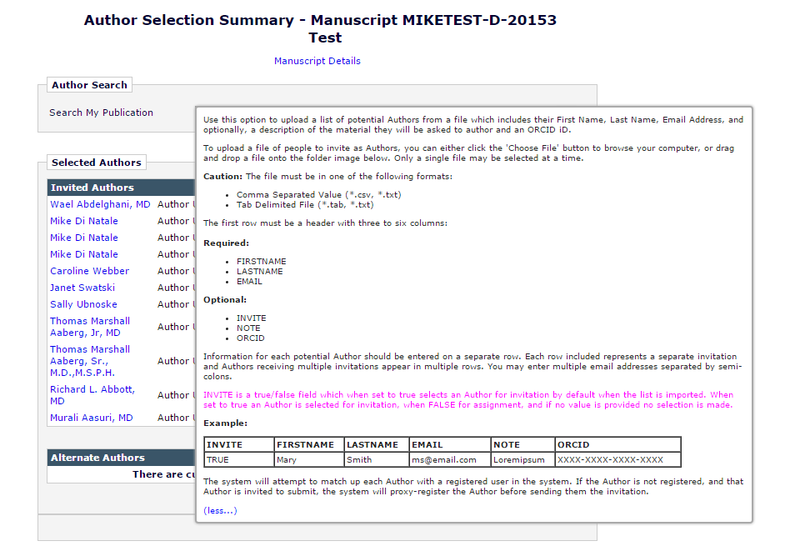

- The ‘Selected Authors’ section of the Author Selection Summary page is enhanced
  - Within the section, the ‘Invited Authors’ grid is displayed
    - The ‘Invited Authors’ grid currently lists all Authors who have been invited to submit
      - Each row in the table contains:
        - The Author’s full name and degree
        - The status of the invitation with a date/time stamp
        - A link to view the related letter
        - An ‘Un-invite’ or ‘Un-assign’ link, when invitation or assignment is in progress
          - Editors will have access to either link via either the new ‘Assign Authors (without Invitation)’ permission or the existing ‘Invite Authors/Solicit Commentaries’ permission
            - Editors will be able to use these links to remove Authors regardless of how the Author was solicited or how Editors are permissioned to solicit Authors
          - New in this spec the existing ‘Un-invite’ link is enhanced such that it is available for an Author only prior to accepting an invitation
          - New is this spec a new ‘Un-assign’ link is available for assigned Authors and authors who accepted an invitation prior to submitting the solicited submission
          - The links are suppressed if an Author has been uninvited, unassigned, declined, or has completed the submission process
          - See a.e of Section 2.3 for more information
      - Authors are grouped by status, enhanced by this specification to display three new statuses in addition to the existing five possible statuses for a total of eight
        - New to this specification are ‘Author Assigned’, ‘Author Un-assigned after Agreeing’, and ‘Author Un-assigned after Assignment’ statuses
        - All eight statuses appear below, ordered as they are sorted on the page:
          - Author Complete
          - Agreed to Submit
          - Author Assigned
          - Author Invited
          - Author Declined
          - Author Un-invited
          - Author Un-assigned after Agreeing
          - Author Un-assigned after Assigning
    - The ‘Invited Authors’ grid is enhanced to include Authors who have been assigned a submission
      - Invited Authors continue to display in the grid as they do today when initially invited and receive the ‘Author Invited’ status
        - If the Author accepts the status will continue to display as ‘Agreed to Submit’
        - If the Author declines the status will continue to display as ‘Author Declined’
        - New in this specification an ‘Un-assign’ link appears for invited submissions where the Author has accepted, previously this was an ‘Un-invite’ link
          - When this link is used to unassign the Author the new ‘Author Un-assigned after Agreeing’ status will be displayed
            - The status will display with the same color and format as the ‘Author Un-invited’ status does today for invited submissions where the Author has agreed
              - Text is black
              - The status text, as per existing functionality is followed by a hyphen and then a date/time stamp using the site’s configured format
            - Example: Author Un-assigned - Nov 05 2015 03:34PM
        - Using the ‘Un-assign’ link for an invited submission will promote available Alternate Authors as is the case today when using the ‘Un-invite’ link
        - The existing ‘Un-invite’ link continues to appear for invited Authors prior to an invitation being accepted
          - The ‘Un-invite’ link continues to function as it does today
      - Assignments are incorporated using the existing functionality, but using a mix of the old and new statuses
        - Assignments are displayed in the grid with invitations, grouped by status and ordered as noted above
      - If an Author is assigned a submission
        - A row for the Author is added to the ‘Invited Authors’ grid, populating as it would if the Author had been invited and accepted, with the exception of status term and appearance of the new ‘Un-assign’ link
          - The row has four columns
          - A column is available for:
            - The name of the Author
            - The status of their connection to the parent submission
            - A link to the letter notifying them of their assignment
            - A link which will end their assignment – when available
              - For an Author selected by assignment the link would always be ‘Un-assign’ when present
        - The assigned Author names will be listed as they are today for invited Authors
          - The first, middle, and last name of the Author, as well as the degree, will display as a link to the Author’s People Information page [reviewer_info.asp]
          - The set flag icon and any People Flags associated with a user record will display to the right of the name when Editors are permissioned to view and add People Flags, as is the case in the existing functionality
        - The Author is listed in the table with the new ‘Author Assigned’ status
          - The status will display with the same color and format as the ‘Agreed to Submit’ status does today for invited submissions where the Author has agreed
            - Text is EM orange (#EE6600)
            - The status text, as per existing functionality is followed by a hyphen and then a date/time stamp using the site’s configured format
          - Example: Author Assigned - Nov 05 2015 03:34PM
        - The ‘View Letter’ link will open the View Letter page [viewLetter.asp] for the assignment letter sent to the Author when the new ‘Author Assigned (Not Invited)’ event is triggered (if one is configured to be sent)
        - An ‘Un-assign’ link will appear in the fourth column when an assigned Author can be removed
          - The ‘Un-assign’ link is new to the Author Selection Summary page in this specification
          - The system will treat assigned Authors as Authors who have agreed to submit via invitation
          - As such, the new ‘Un-assign’ link will also display for invited Authors who have accepted an invitation in order to create clear, consistent language on the page
            - The ‘Un-invite’ link will continue to appear for invited Authors who have not yet accepted an invitation
          - Clicking the ‘Un-assign’ link will direct a user to an enhanced layout of the Un-invite Author page (See Section 2.4) where they will be able to remove an Author who has been assigned to a submission, functioning identically to the ‘Un-invite’ link when used for an accepted invitation in the existing functionality
            - Note: Removing assigned and invited Authors via the ‘Un-assign’ link will trigger different ActionManager events(See Sections 2.2 and 2.4 for more information
            - Removing an Author selected via assignment will not trigger the promotion of Alternate Authors
          - Once unassigned, an Author selected by assignment is listed in the table with the new ‘Author Un-assigned’ status
            - The status will display with the same color and format as the ‘Author Un-invited’ status does today for invited submissions where the Author has agreed
              - Text is black
              - The status text, as per existing functionality is followed by a hyphen and then a date/time stamp using the site’s configured format
            - Example: Author Un-assigned - Nov 05 2015 03:34PM
        - Access to both the ‘Un-invite’ and ‘Un-assign’ links is available to Editors with either the new ‘Assign Authors (without Invitation)’ permission or the existing ‘Invite Authors/Solicit Commentaries
          - Editors will be able to use these links to remove Authors regardless of how the Author was solicited or how Editors are permissioned to solicit Authors
  - The ‘Alternate Authors’ grid on the Author Selection Summary page is enhanced
    - The ‘Alternate Authors’ grid will be suppressed for Editors configured with the new ‘Assign Authors (without Invitation)’ permission AND who to do not also have the existing ‘Invite Authors/Solicit Commentaries’ permission enabled when no Alternate Authors have been selected
      - An Editor with permission only to assign Authors would only need to see the ‘Alternate Author’ grid if another Editor had selected them
      - In existing functionality selected Alternates are visible to Editors without permission to search, remove, or promote them
        - The grid remains visible to anyone with the existing ‘Invite Authors/Solicit Commentaries’ permission, per existing functionality
  - All Editors viewing the page will be able to see the status of any solicited Authors in the Selected Authors grid, regardless of whether they are invited or assigned

Figure 6: Mock-up of the Author Selection Summary page following the implementation of the assign Author functionality. Assigned Authors will appear on the page listed under the ‘Author Assigned’ status. Assigned Authors will also be able to be removed using the new ‘Un-assign’ link associated with their record. The ‘Un-assigned’ link will also be used for Authors with accepted invitations. Authors who have been unassigned will remain on the page and displayed with the ‘Author Un-assigned’ status. The ‘Alternate Authors’ grid is available because the Editor viewing the page has the ‘Invite Authors/Solicit Commentaries’ permission.
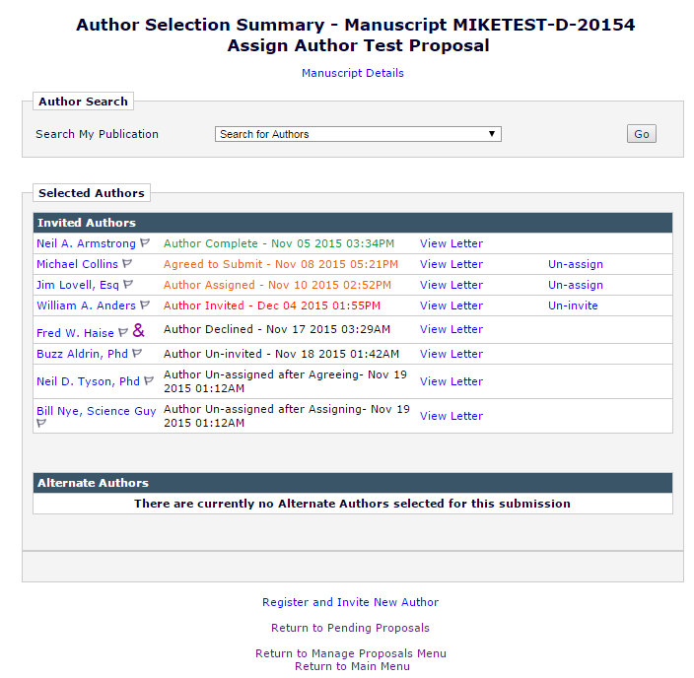

Figure 6b: This mock up is the same as Figure 6, with one notable exception - The ‘Alternate Authors’ grid is NOT available because none have been selected and the Editor viewing the page has only the new ‘Assign Authors (without Invitation)’ permission enabled and not the ‘Invite Authors/Solicit Commentaries’ permission. If another Editor has selected Alternates they will be displayed.
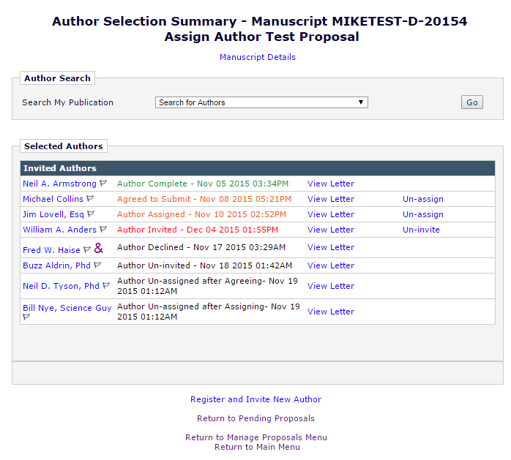

Un-invite Author page [confirmAndCustomizeUninvitedAuthors.aspx]
The Un-invite Author page is reached from the Author Selection Summary page by clicking the ‘Un-invite’ link for a selected Author. The page opens in a pop-up window. New in this specification users will access this page from the newly created ‘Un-assign’ link which has been added to the Author Selection Summary page.

Authors who are assigned under the new functionality introduced by this specification will be able to be removed by Editors on the Author Selection Summary page. In the existing functionality Editors with the ‘Invite Authors/Solicit Commentaries’ permission are able to uninvite Authors using the ‘Un-invite’ link on the Author Selection Summary page which is available once an Author is invited until they submit the solicited submission. This specification extends the ability to uninvite/unassign Authors to Editors with the new ‘Assign Authors (without Invitation)’ permission and adds a new ‘Un-assign’ link to the Author Selection Summary page. The new link will be available when an Editor has been assigned or accepted an invitation, leaving the existing ‘Un-invite’ link in place only prior to an Author accepting an invitation. The Un-invite Author page will be enhanced with a new layout which will reflect the new language presented by the ‘Un-assign’ link. When the ‘Un-assign’ link is used to reach the Un-invite Author page, appropriate language will be used.

Authors who are uninvited after being assigned will continue to be listed within the Invited Authors grid that is part of the Selected Authors section of the Author Selection Summary page, as is the case currently with invited Authors uninvited after Agreeing, showing a status reflecting what has occurred.

The intention is to model the addition of the ‘Assign Author’ functionality after the implementation of the ‘Assign Reviewer’ functionality added by Spec 9.0-53 where assignments were treated as accepted invitations; the act of assigning Authors sets all fields as if an invitation was accepted the moment it was sent.

Unassigning an Author who was assigned to a submission will not trigger the promotion of Alternate Authors. Unassigning an Author who accepted an invitation will continue to promote Alternate Authors when dictated by the existing configuration options

New Functionality:
- Un-invite Author page [confirmAndCustomizeUninvitedAuthors.aspx] is enhanced with new layouts which appear depending on how the page is reached
  - Under the enhancements detailed in Section 2.3 the page will be reached from either an ‘Un-invite’ or ‘Un-assign’ link available on the Author Selection Summary page
    - When the Un-invite Author page [confirmAndCustomizeUninvitedAuthors.aspx] is accessed from the existing ‘Un-invite’ link it appears and functions as it does today under existing functionality
    - When the Un-invite Author page [confirmAndCustomizeUninvitedAuthors.aspx] is accessed from the new ‘Un-assign’ link the layout is of the page is changed, though it serves the same purpose as in the existing functionality
      - The page header is labeled to “Un-assign Author”
      - The existing warning text is updated to:
        - You are about to Un-assign AUTHOR FULL NAME. This action will terminate this person’s assignment to submit a manuscript related to the PARENT SUBMISSION MANUSCRIPT NUMBER “PARENT SUBMISSION FULL TITLE”.
          - Where AUTHOR FULL NAME is the First, Middle, and Last name of an Author followed by their degree
          - Where PARENT SUBMISSION MANUSCRIPT NUMBER is the manuscript number of the associated parent submission
          - Where PARENT SUBMISSION FULL TITLE is the manuscript number of the associated parent submission
        - If automated promotion of Alternate Authors is enabled for the parent submission AND the Author being unassigned was originally invited, additional warning text is present:
          - You are about to Un-assign AUTHOR FULL NAME. This action will terminate this person’s ongoing assignment to submit a manuscript related to the PARENT SUBMISSION MANUSCRIPT NUMBER “PARENT SUBMISSION FULL TITLE”. If there is an Alternate Author in the queue, they will be promoted in this Author’s place and will be sent the selected Alternate Author Invitation Letter.
            - Where capitalized text represents the same values as above
      - The existing help text is updated (changes highlighted, but not be coded in pink)
        - The text of the collapsed help text will read:
          - “You are not required to send notification letters to Authors if they are un-assigned.
        - The text of the expanded help text will read:
          - You are not required to send notification letters to Authors if they are un-assigned. However, if you do not send a letter, the assignment will no longer appear in the Author's folders with no explanation. Therefore, it is recommended that you send a Un-assignment Letter, explaining to the person why his/her services are no longer required for the assignment. If an Author has a work in progress it will remain in their Incomplete Submissions folder.
To change the letter sent to an individual person, click the Letter drop-down box next to that person's name and select a different letter.
Click Customize if you want to customize a particular letter. Once you have customized a letter, an asterisk is displayed next to the person's name. If you do not explicitly customize the letter for a particular person, the default letter will be sent.
Note: If you customize a letter and then select a new letter, your customized text will be lost.
      - The existing letter selection grid remains intact, however, the behavior determining the default selected letter is enhanced
        - The default letter in the drop-down menu is the letter associated with the either the new ‘Author Unassigned after Accepting Invitation’ of the new ‘Author Unassigned after Assignment’ ActionManager events (if one is configured)
          - The event used depends on whether the Author was originally invited or assigned
            - ‘Author Unassigned after Accepting Invitation’ is used when an Author was invited, accepted and then unassigned
            - ‘Author Unassigned after Assignment’ is used when an Author was selected by assignment
        - The drop-down menu is populated with any letter in the Author Invitation letter family per existing functionality
      - For this new layout the existing [Un-invite and Send Letter] button is relabeled “Un-assign and Send Letter”
        - Clicking this button will, as per existing functionality, directs the Editor to the Un-invite E-mail Confirmation page (See Section 2.5)

- Once an Author is unassigned the change in their assignment status and relationship to any in-progress work must be noted in the database
  - This change in status will be reflected on the Author Selection Summary page
  - If the Author being unassigned was selected via assignment no Alternate Authors will be promoted when the Author is removed
  - Engineering will determine where Author assignment records are stored, but if the Invited Authors table is used, as suggested, to store the assignment records as well as the existing invitation records the table would the change by setting INVITED_AUTHORS.UNINVITED to TRUE and recording the date/time in the INVITED_AUTHORS.UNINVITE_DATE
  - If an Author had a work in progress when unassigned, the in-progress manuscript from the assigned Author remains in the Author’s Incomplete Submissions folder
    - When accessed again the Author will need to update the Article Type if they wish to submit their work as an unsolicited submission
    - This is how orphaned solicited submissions are handled in the existing invited workflow functionality

Figure 7: Mock-up of the new layout of the Un-invite Author page showing the updated text and letter template tied to the new ‘Author Unassigned’ ActionManager event appearing as the default selection. The Unassign Author letter appears because it is configured for the Author Role’s ‘Author Unassigned after Assignment’ event and the Author was assigned to submit.
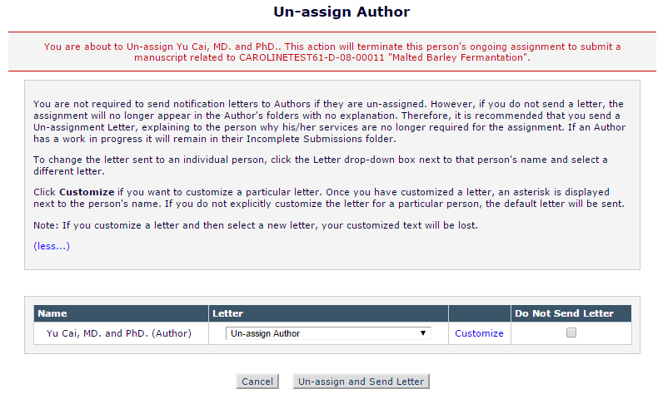

Figure 7b: Mock-up of the new layout of the Un-invite Author page showing the updated text and letter template tied to the new ‘Author Unassigned after Accepting Invitation’ ActionManager event appearing as the default selection. This mock up shows the Alternate Author related text in the top section of the page which appears when the Author being unassigned was originally invited.
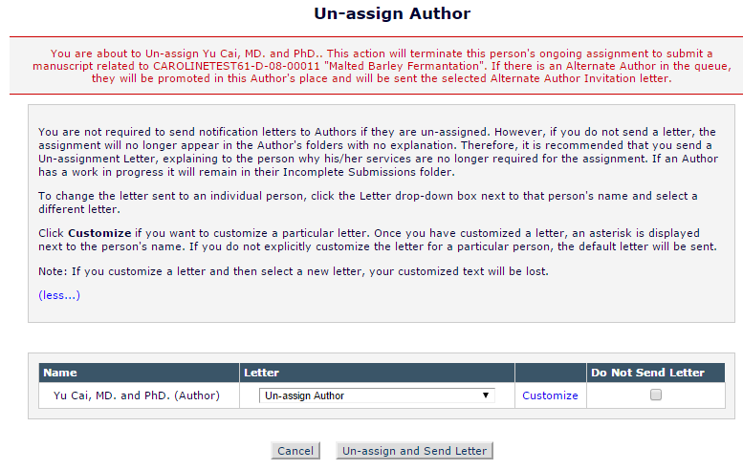

Un-invite E-Mail Confirmation page [sendMultipleCustomAuthorInvLetters.asp]
The Un-invite E-Mail Confirmation page is reached by clicking the [Un-invite and Send Letter] button on the Un-invite Author page. Upon clicking that button users are brought to this confirmation page and a message displays indicating that the Author has received a notification letter regarding their removal.

This page is enhanced in order to display different layouts depending on the action which has led a user to this page. This specification adds a ‘Un-assign’ option to the Author Selection Summary page (See Section 2.3) for Authors who have been assigned or Authors who have accepted an invitation. In order to be consistent with the new option dual layouts will be created for the existing Un-invite E-Mail Confirmation page so that the language on the page matches the action implied by the link.

New Functionality:
- The Un-invite E-Mail Confirmation page is enhanced to offer separate layouts depending on whether a user was uninvited or unassigned
  - Under the new functionality, an Author can be uninvited prior to accepting and invitation to submit; Authors who have accepted an invitation or have been directly assigned are unassigned
- The layout for the ‘Un-invited’ workflow is identical to the existing page
  - The confirmation message on the page varies depending on whether or not the Author was sent a notification, per existing functionality (See Figure 8 and 8b)

Figure 8: Un-invite E-mail Confirmation page following an Author being uninvited. This confirmation page is identical to what is displayed today when an Author is uninvited. 

Figure 8b: Un-invite E-mail Confirmation page following an Author being uninvited without receiving a notification letter. This confirmation page is identical to what is displayed today when an Author is uninvited.
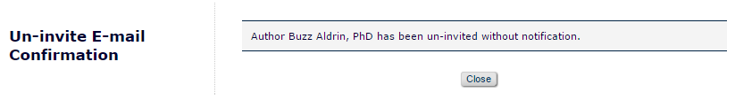

- The layout for the ‘Un-assigned’ workflow updates the text on the existing page while maintaining the current format
  - The header text is relabeled: “Un-assign E-Mail Confirmation”
  - The confirmation message on the page varies depending on whether or not the Author was sent a notification
    - When an Author is sent a notification letter the updated text reads: “An Author Un-assigned Notice has been sent to AUTHOR FULL NAME”
    - When an Author is NOT sent a notification letter the updated text reads: “Author [AUTHOR FULL NAME] has been un-assigned without notification”
    - [AUTHOR FULL NAME] is populated with the Author’s First, Middle, and Last names followed by their degree
  - No other changes are made to the page

Figure 8c: Un-invite E-mail Confirmation page mocked up with the new ‘Un-assign’ layout. This confirmation message is displayed when an Author is unassigned and a notification letter is sent.
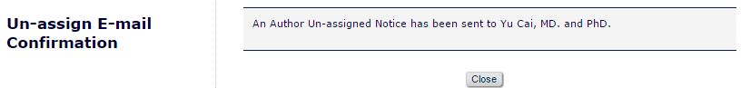

Figure 8d: Un-invite E-mail Confirmation page mocked up with the new ‘Un-assign’ layout. This confirmation message is displayed when an Author is unassigned and no notification is sent.
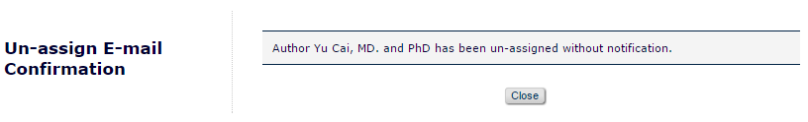

Search for Authors by Name Results page [searchAuthorsByNameAddrResults.asp]
Users access the Search for Authors by Name Results page from the Author Selection Summary page after selecting ‘Search for Authors’ from the search drop down and clicking the [Go] button to arrive at the Search for Authors by Name page [searchAuthorsByNameAddr.asp]. Once a search query is run users will be brought to the Search for Authors by Name Results page to view the results of their search.

The Search for Authors by Name Results page is enhanced by this specification in order to account for the ability to assign Authors directly in addition to invitation. Changes to the page layout will be visible to all users regardless of the new permission being enabled; however, users configured with the new ‘Assign Author (Commentaries/Proposals)’ permission will have access to functionality on this page which was previously unavailable and which will allow them to select Authors for assignment rather than invitation.

Existing Functionality:
- Search Results are displayed in an ‘Author Candidates’ grid
- Editors are limited to inviting Authors
  - A ‘Select’ column is displayed containing a checkbox for each record displayed in the search results
  - When selected, each Author in the results may have a number of invitation letters entered, controlling how many invitations will be sent to an individual
- Selected Authors are carried over to the Select Authors – Confirm Selection and Customize Letters page when the [Proceed] button is clicked at the bottom of the page

Figure 9: Existing Search for Authors by Name Results page.
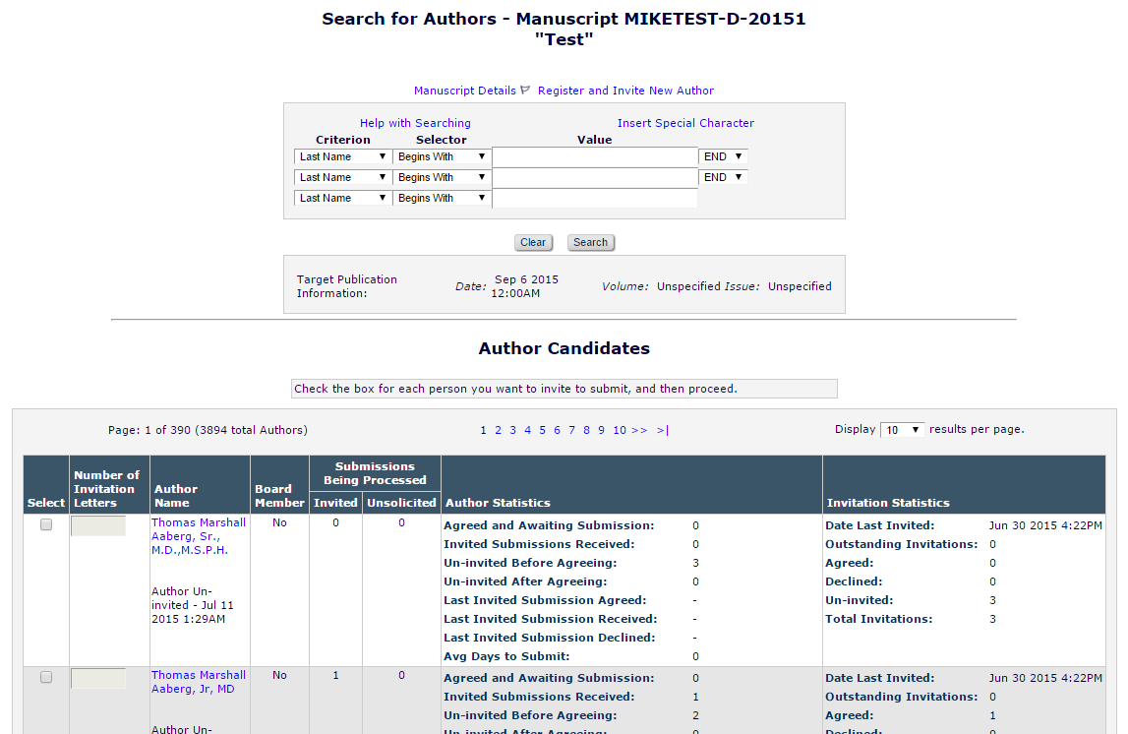

New Functionality
- The ‘Author Candidates’ instructions are enhanced
  - The existing instructions replaced with new text addressing the new assignment functionality
    - The existing text is removed
    - The new text uses the existing text’s font, size, and color
    - The new text is inserted into the existing grey box
    - The new instructional text is expandable,
    - The text initially appears as collapsed when search results are loaded
      - The collapsed text includes a portion of the full text followed by a “(more…)” link
      - The collapsed text reads: “Select a checkbox for each person you wish to select as an Author”
      - When the “(more…)” link is clicked the grey box is expanded to show the full text
        - When expanded the “(more...)” link becomes a “(less…)” link
        - Additional text is displayed: “Depending on your permissions, you may select Authors to be Invited ("Inv.") or Assigned ("Asn."). Your selection may vary Author to Author, but each individual may only be selected for invitation or assignment. Your selections will be retained when you change to a different results page or change the search.”
        - When the “(less…)” link is clicked the grey box returns to its initial state and the additional text is hidden

Example: Mock-up of collapsed instructional text
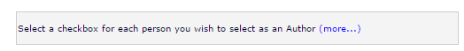

Example: Mock-up of expanded instructional text
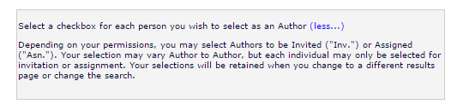

- The ‘Author Candidates’ grid is enhanced
- The ‘Number of Invitation Letters’ column header is relabelled ‘Number of Letters’
  - Reflects that letters can be invitations or assignments
- The ‘Select’ column is enhanced to display a combination of invitation AND assignment checkboxes based on an Editor’s RoleManager permissions
  - This column is modeled after the ‘Select’ column found in Reviewer search results
    - The header cell is split horizontally to provide space for selection type labels
      - Two labels are possible based on an Editor’s permission set
        - “Inv.”
          - Standing for invite
        - “Asn.”
          - Standing for assign
      - Both labels may display at the same time or appear individually
      - Selection labels are formatted as headers with white, bold text against an EM blue background
    - If an Editor’s permissions allow both options to display the ‘Select’ header is relabelled as ‘Select As’
  - When a user has only the Invite Assign/Solicit Commentaries permission:
    - ‘Select As’ is labelled as ‘Select’
    - The “Inv.” label appears below ‘Select’
    - A single column with a checkbox appears for each user in the search result
      - When the checkbox is selected the user will receive an invitation to submit
      - The checkbox is centered in the column
  - When a user has only the Assign Authors (without Invitation) permission
    - ‘Select As’ is labelled as ‘Select’
    - The “Asn.” label appears below ‘Select’
    - A single column with a checkbox appears for each user in the search result
      - When the checkbox is selected the user will receive an assignment which will allow them to submit into the system
      - The checkbox is centered in the column
  - When a user has both the Invite Assign/Solicit Commentaries and Assign Authors (without Invitation) permissions
    - The “Inv.” and “Asn.” labels appears below ‘Select As’
      - Each appears in a separate column which divides the ‘Select As’ column
      - “Inv.” appears in the left column
      - “Asn.” appears in the right column
    - A column corresponding with each label divides the ‘Select As’ column for each result
      - A checkbox appears in each column for each user in the search result
        - Each checkbox is centered in the column it has been placed in
      - When the checkbox in the “Inv.” labelled column is selected the user will receive an invitation to submit
      - When the checkbox in the “Asn.” labelled column is selected the user will receive an assignment which will allow them to submit into the system
      - Only one of the checkbox options may be selected per Author at any given time
        - Selecting one option for a user will unselect the other, if it is already selected
        - Different checkbox selection between separate user accounts in the result set is allowed
- Information in remaining columns appears as it does currently, per existing functionality
- No direct changes to the Author statistic column occurs
  - Assignment data will be reflected in the existing fields
  - How assignments impact Author statistics is detailed in Section 2.14
- No direct change to the Invitation Statistics column occurs
  - Assignment data will be reflected in the existing fields
  - How assignments impact Author statistics is detailed in Section 2.14

Figure 10: Mock-up of Search for Author by Name Results page as viewed by an Editor with both the ‘Invite Assign/Solicit Commentaries’ and ‘Assign Authors (without Invitation)’ permissions enabled.
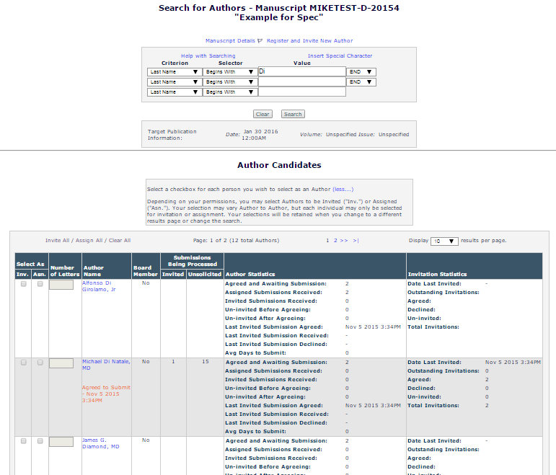

Figure 11: Mock-up of Search for Author by Name Results page as viewed by an Editor with only the ‘Invite Assign/Solicit Commentaries’ permission enabled.
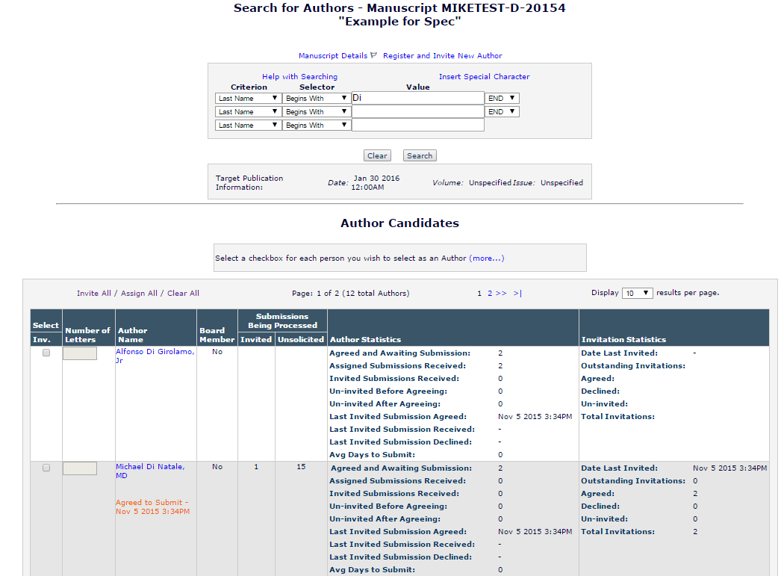

Figure 12: Mock-up of Search for Author by Name Results page as viewed by an Editor with only the ‘Assign Authors (without Invitation)’ permission enabled.
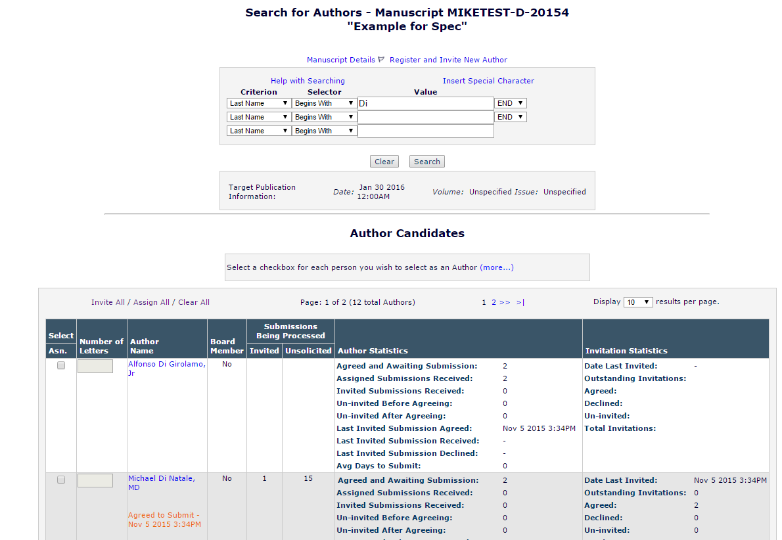

Search for Authors by Personal Classifications Results page [searchAuthorsByPersonalClassResults.asp]
Users access the Search for Authors by Personal Classifications Results page from the Author Selection Summary page after selecting ‘Search by Personal Classifications’ from the Author search drop down and clicking the [Go] button to arrive at the Search for Authors by Personal Classification page [searchAuthorsByPersonalClass.asp]. Once a search query is run users will be brought to Search for Authors by Personal Classifications Results page to view the results of their search.

The Search for Authors by Personal Classifications Results page is enhanced by this specification in order to account for the ability to assign Authors directly in addition to invitation. Changes to the page layout will be visible to all users regardless of the new permission being enabled; however, users configured with the new ‘Assign Author (Commentaries/Proposals’ permission will have access to functionality on this page which was previously unavailable and which will allow them to select Authors for assignment rather than invitation.

Existing Functionality:
- Search Results are displayed in an Author Candidates grid
- Editors are limited to inviting Authors
  - A ‘Select’ column is displayed containing a checkbox for each record displayed in the search results
  - When selected, each Author in the results may have a number of invitation letters entered, controlling how many invitations will be sent to an individual
- Selected Authors are carried over to the Select Authors – Confirm Selection and Customize Letters page when the [Proceed] button is clicked at the bottom of the page

New Functionality:
- The ‘Author Candidates’ instructions are enhanced
  - The existing instructions replaced with new text addressing the new assignment functionality
    - The existing text is removed
    - The new text uses the existing text’s font, size, and color
    - The new text is inserted into the existing grey box
    - The new instructional text is expandable,
    - The text initially appears as collapsed when search results are loaded
      - The collapsed text includes a portion of the full text followed by a “(more…)” link
      - The collapsed text reads: “Select a checkbox fir each person you wish to select as an Author”
      - When the “(more…)” link is clicked the grey box is expanded to show the full text
        - When expanded the “(more...)” link becomes a “(less…)” link
        - Additional text is displayed: “Depending on your permissions, you may select Authors to be Invited ("Inv.") or Assigned ("Asn."). Your selection may vary Author to Author, but each individual may only be selected for invitation or assignment. Your selections will be retained when you change to a different results page or change the search.”
        - When the “(less…)” link is clicked the grey box returns to its initial state and the additional text is hidden
- The ‘Author Candidates’ grid is enhanced
- The ‘Number of Invitation Letters’ column header is relabelled ‘Number of Letters’
  - Reflects that letters can be invitations or assignments
- The ‘Select’ column is enhanced to display a combination of invitation AND assignment checkboxes based on an Editor’s RoleManager permissions
  - This column is modeled after the ‘Select’ column found in Reviewer search results
    - The header cell is split horizontally to provide space for selection type labels
      - Two labels are possible based on an Editor’s permission set
        - “Inv.”
          - Standing for invite
        - “Asn.”
          - Standing for assign
      - Both labels may display at the same time or appear individually
      - Selection labels are formatted as headers with white, bold text against an EM blue background
    - If an Editor’s permissions allow both options to display the ‘Select’ header is relabelled as ‘Select As’
  - When a user has only the ‘Invite Assign/Solicit Commentaries’ permission:
    - ‘Select As’ is labelled as ‘Select’
    - The “Inv.” label appears below ‘Select’
    - A single column with a checkbox appears for each user in the search result
      - When the checkbox is selected the user will receive an invitation to submit
      - The checkbox is centered in the column
  - When a user has only the ‘Assign Authors (without Invitation)’ permission
    - ‘Select As’ is labelled as ‘Select’
    - The “Asn.” label appears below ‘Select’
    - A single column with a checkbox appears for each user in the search result
      - When the checkbox is selected the user will receive an assignment which will allow them to submit into the system
      - The checkbox is centered in the column
  - When a user has both the ‘Invite Assign/Solicit Commentaries’ and ‘Assign Authors (without Invitation)’ permissions
    - The “Inv.” and “Asn.” labels appears below ‘Select As’
      - Each appears in a separate column which divides the ‘Select As’ column
      - “Inv.” appears in the left column
      - “Asn.” appears in the right column
    - A column corresponding with each label divides the ‘Select As’ column for each result
      - A checkbox appears in each column for each user in the search result
        - Each checkbox is centered in the column it has been placed in
      - When the checkbox in the “Inv.” labelled column is selected the user will receive an invitation to submit
      - When the checkbox in the “Asn.” labelled column is selected the user will receive an assignment which will allow them to submit into the system
      - Only one of the checkbox options may be used per user at any given time.
        - Selecting one option for a user will unselect the other, if it is already selected
        - Different checkbox selection between users in the result set is allowed
- Information in remaining columns appears as it does currently, per existing functionality
- No direct changes to the Author statistic column occurs
  - Assignment data will be reflected in the existing fields
  - How assignments impact Author statistics is detailed in Section 2.14
- No direct change to the Invitation Statistics column occurs
  - Assignment data will be reflected in the existing fields
  - How assignments impact Author statistics is detailed in Section 2.14

Figure 13: Mock-up of Search for Author by Personal Classifications Results page as viewed by an Editor with both the ‘Invite Assign/Solicit Commentaries’ and ‘Assign Authors (without Invitation)’ permissions enabled.

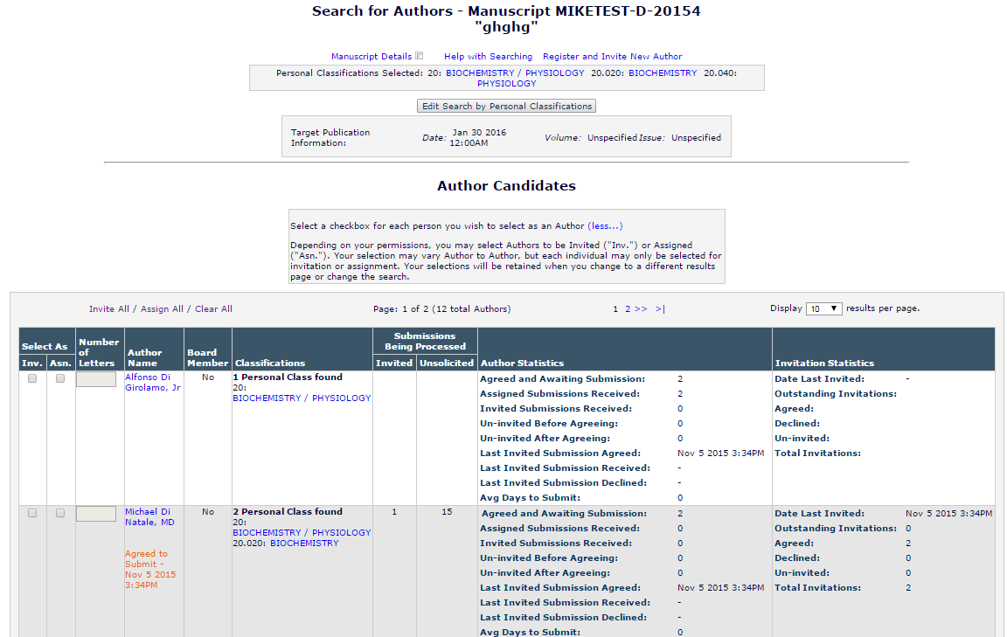

Figure 14: Mock-up of Search for Author by Personal Classifications Results page as viewed by an Editor with only the ‘Invite Assign/Solicit Commentaries’ permission enabled.
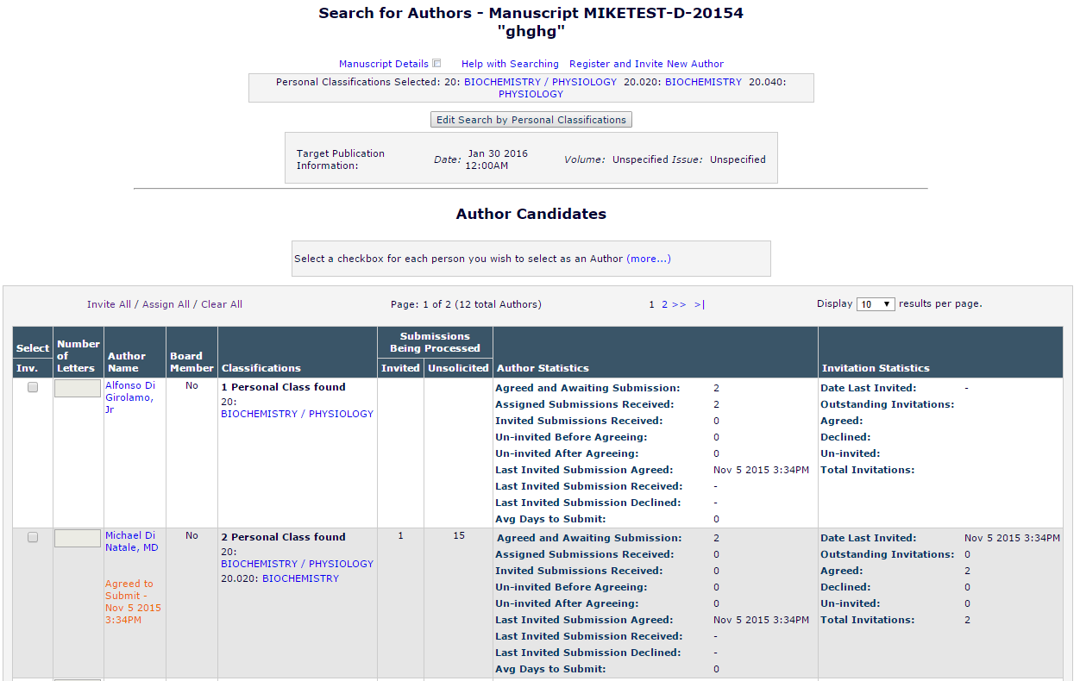

Figure 15: Mock-up of Search for Author by Personal Classifications Results page as viewed by an Editor with only the ‘Assign Authors (without Invitation)’ permission enabled.
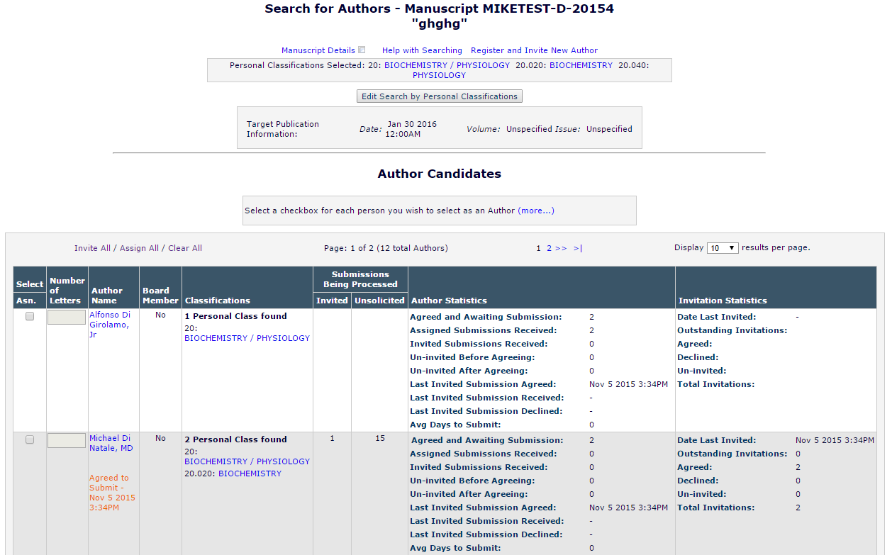

Upload Author List page [uploadAuthorList.aspx]
The Upload Author List page is reached by selecting the ‘Upload Author List’ option from the Author Search dropdown menu on the Author Selection Summary page and then clicking the [Go] button. The purpose of the page is to facilitate the upload of an Author List File (ALF) by an Editor into the system. The same warning text available from the information icon on the Author Selection Summary page is present here so that Editors will have access to the instructions as they are uploading the ALF.

The core functionality of this page is unchanged by this specification; however the enhancements to the page are made to add instructional support for the new Author assignment functionality and its interaction with the ALF.

- The Upload Author List page instructional text is enhanced
  - The instructions on the Upload Author List page are updated to include information about the Author Assignment functionality
  - The instructions are located within the ‘Upload Author List’ grid placed on the page
    - The instructional text is expandable/collapsible using more/less links
  - The collapsed version of the text is unchanged by this specification
  - The expanded text is updated as follows, new text is highlighted, but not be coded, in pink:

Use this option to upload a list of potential Authors from a file which includes their First Name, Last Name, Email Address, and optionally, a description of the material they will be asked to author and an ORCID iD.

To upload a file of people to invite as Authors, you can either click the 'Choose File' button to browse your computer, or drag and drop a file onto the folder image below. Only a single file may be selected at a time.

Caution: The file must be in one of the following formats:
- Comma Separated Value (*.csv, *.txt)
- Tab Delimited File (*.tab, *.txt)

The first row must be a header with three to seven columns:
Required:
- FIRSTNAME
- LASTNAME
- EMAIL
Optional:
- INVITE
- TITLE
- NOTE
- ORCID

Information for each potential Author should be entered on a separate row. Each row included represents a separate invitation and Authors receiving multiple invitations appear in multiple rows. You may enter multiple email addresses separated by semi-colons.

INVITE is a true/false field which will determine how an Author is selected by default when the list is imported. When set to TRUE an Author is selected for invitation, when FALSE for assignment, and if no value is provided no selection is made.

Example:
INVITE | FIRSTNAME | LASTNAME | EMAIL | ORCID | TITLE | NOTE
TRUE | Mary | Smith | ms@email.com | XXXX-XXXX-XXXX-XXXX | Chapter 1 | Loremipsum

The system will attempt to match up each Author with a registered user in the system. If the Author is not registered and that Author is invited to submit, the system will proxy-register the Author before sending them the invitation.

Figure 16: Mockup of Upload Author List page featuring updated instructional text
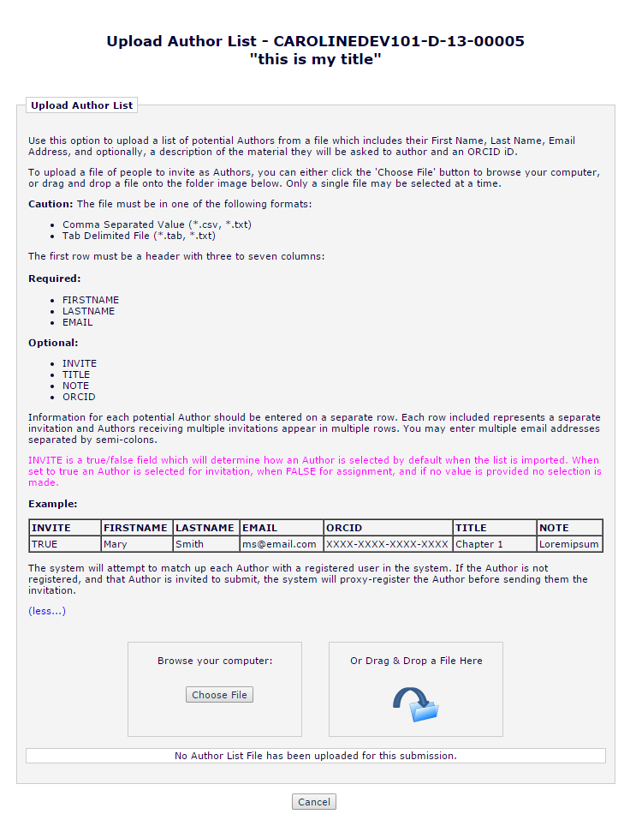

‘Author Candidates’ Results page [UploadedAuthorSearchResults.aspx]
Users access the ‘Author Candidates’ Results page from the Author Selection Summary page after selecting ‘Upload Author List’ from the search drop-down menu and clicking the [Go] button to arrive at the Upload Author List page. Once a file is uploaded and imported users will be brought to ‘Author Candidates’ Results page to view the matches to the existing database from the file and to review any duplicates or issues with the imported records.

The ‘Author Candidates’ Results page is enhanced in order to allow the direct assignment of Authors by Editors when submissions are solicited. The system will now interpret a FALSE value in the INVITE column of an uploaded Author List File (ALF) to indicate that the Author should be selected for assignment rather than invitation. A value of TRUE will select an Author for invitation and a no value will now indicate that a user not initially be selected for either invitation or assignment. Values entered in the INVITE column of the file other than TRUE or FALSE will be treated as no value by the system. (See Section 2.9.1)

Editors using an ALF to select Authors will be able to select them for assignment with or without the new RoleManager permission being enabled in order to limit errors. This is allowed in order to prevent data included in the ALF from being ignored or discarded without being used. The philosophy behind the ALF since its inception has been to use all of the data included in the file regardless of system settings and is in keeping with the existing functionality supporting the ALF which allows predefined titles (Spec 13.0-31) to be uploaded with or with the related RoleManager permissions.

Thus at upgrade anyone able to upload an ALF will be able to preselect Authors for invitation or assignment and when viewing the selections in the interface change the selection as needed regardless of the Editor’s RoleManager configuration including the new ‘Assign Authors (without Invitation)’ permission or the existing ‘Invite Authors/Solicit Commentaries’ permission, though one of these permissions would be required to access the Author Selection Summary page where an ALF would be uploaded.

The ‘Select’ column on the ‘Author Candidates’ Results page will be relabeled as ‘Select As’ and separate columns for “Inv.” and “Asn.” will always be displayed. In order to prevent ALF uploads from being held up or ignore valid information, Editors using an ALF to select Authors will be able to assign Authors without having the specific RoleManager permission to do so. This mimics the accessibility to functionality when using an ALF afforded to the ability to predefine submission title values (Spec 13.0-31). In that case predefined titles in the ALF were ingested regardless of an Editor’s permissions.

New Functionality:
- The ‘Author Candidates’ instructions are enhanced
  - The existing instructions replaced with new text addressing the new assignment functionality
    - The existing text is removed
    - The new text uses the existing text’s font, size, and color
    - The new reads: “Select a checkbox for each person you wish to select as an Author. You may select Authors to be Invited ("Inv.") or Assigned ("Asn."). Your selection may vary Author to Author, but each individual may only be selected for invitation or assignment.”
- The ‘Author Candidates’ grid is enhanced
- The ‘Number of Invitation Letters’ column header is relabelled ‘Number of Letters’
  - Reflects that letters can be invitations or assignments
- The existing ‘Select’ column is relabelled as ‘Select As’
  - Necessary as multiple selection options will always appear on this page
- The ‘Select As’ column will display invitation AND assignment checkboxes
  - This column is modeled after the ‘Select’ column found in Reviewer search results
  - The header cell is split horizontally to provide space for the two selection type labels
    - The two labels are:
      - “Inv.”
      - “Asn.”
    - Both labels are always displayed, regardless of an Editor’s RoleManager permissions
    - Selection labels are formatted as headers with white, bold text against an EM blue background
- The “Inv.” and “Asn.” labels appears below ‘Select As’
  - Each appears in a separate column which divides the ‘Select As’ column
    - “Inv.” appears in the left column
    - “Asn.” appears in the right column
  - A column corresponding with each label divides the ‘Select As’ column for each result
    - A checkbox appears in each column for each user in the search result
      - Each checkbox is centered in the column it has been placed in
    - When the checkbox in the “Inv.” labelled column is selected the user will receive an invitation to submit
    - When the checkbox in the “Asn.” labelled column is selected the user will receive an assignment which will allow them to submit into the system
    - Only one of the checkbox options may be selected per user at any given time
    - Different checkbox selection between users in the result set is allowed
- Both columns appear regardless of an Editor’s RoleManager permissions
  - This is a different behaviour than what is seen on the Search for Authors by Name Results page and Search for Authors by Personal Classifications Results page as detailed in Sections 2.6 and 2.7
- Only one of the checkbox options may be used per user at any given time
  - Selecting one option for a user will unselect the other, if it is already selected
  - Different checkbox selection between users in the result set is allowed
- Information in remaining columns appears as it does currently, per existing functionality
- No direct changes to the Author statistic column occurs
  - Assignment data will be reflected in the existing fields
  - How assignments impact Author statistics is detailed in Section 2.14
- No direct change to the Invitation Statistics column occurs
  - Assignment data will be reflected in the existing fields
  - How assignments impact Author statistics is detailed in Section 2.14
- In addition to changes to the user interface, this specification changes how the data from the Author List File (ALF) interacts with this page when determining when to automatically select an Author and which
  - The selection checkboxes may be initially selected depending on the INVITE values in the ALF (See Section 2.9.1)
  - See Section 2.9.1 for complete details

Figure 17: Mocked up ‘Author Candidates’ Results page. In this example the INVITE value for each Author was set to FALSE in the Author List File resulting in the "Asn.” checkbox being enabled initially.
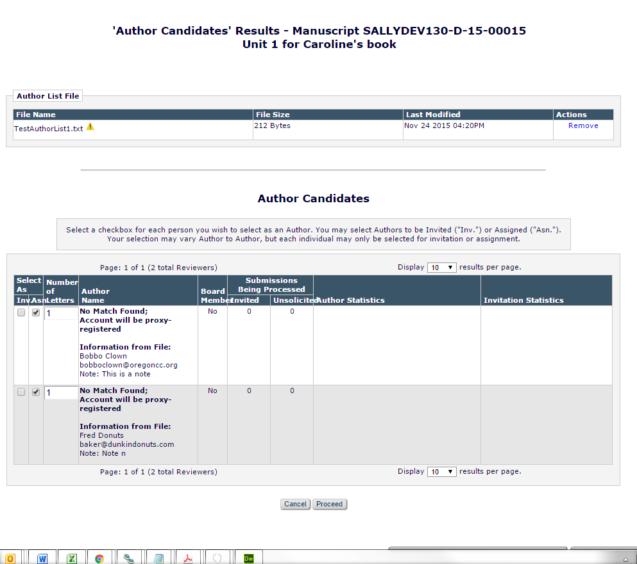

Author List File interaction with ‘Author Candidates’ Results page
As implemented by spec 13.0-18 in EM 13.0, users may upload a list of Authors and use that list to select and/or register Authors for invitation. One of the fields implemented in that specification was INVITE, which is optional. Under the existing functionality, INVITE is a TRUE/FALSE field. If INVITE is TRUE the ‘Select’ checkbox for invitation will be selected for the imported record. Meanwhile, if the value is FALSE or NULL the ‘Select’ checkbox will not be checked off.

This specification enhances the existing process for interpreting the INVITE value such that a FALSE value for this field will result in the new “Asn.” checkbox being selected, while TRUE will continue to represent an invitation by causing the new “Inv.” checkbox to be selected. A NULL value will continue to cause no selection to take place.

Existing functionality:
- Editor uploads an ALF in order to select Authors
- ALF is ingested and imported and Editor is directed to the ‘Author Candidates’ Results page
  - If the INVITE value for a record is TRUE
    - Author is selected for invitation automatically
    - The selection is noted in the ‘Select’ column where the single checkbox displayed for each record is enabled
  - If the INVITE value for a record is FALSE
    - Author is not selected for invitation
    - The checkbox for the record in the ‘Select’ column is not initially enabled
  - If the INVITE value for a record is not provided or any other value other than TRUE or FALSE
    - Author is not selected for invitation
    - The checkbox for the record in the ‘Select’ column is not initially enabled
- If multiple entries for the same record exist in an ALF a count is taken (per Section 2.1.4 of 13.0-18)
  - This count becomes the Number of Invitation Letters value in the ‘Author Candidates’ grid
  - If an author appeared n times in the ALF, they would appear only once in the ‘Author Candidates’ grid with Number of Invitation Letters set to n
  - If between these matched records the INVITE value varies, the value used by a majority of the records is applied, if no one value is in the majority the record will be treated as though INVITE = NULL
- Note: If a record in the ALF has several possible matches with registered users within the EM database the record will not be initially selected for invitation regardless of the INVITE field’s value

New Functionality:
- Editor uploads an ALF in order to select Authors
- ALF is ingested and imported and Editor is directed to the ‘Author Candidates’ Results page
  - If the INVITE value for a record is TRUE
    - Author is selected for invitation automatically
    - The selection is noted in the ‘Select As’ column where the checkbox displayed under the “Inv.” label for a record will be enabled
      - If a record in the ALF is has several possible matches within the EM database the “Inv.” checkbox will not be initially selected regardless of the INVITE field’s value
  - If the INVITE value for a record is FALSE
    - Author is selected for assignment automatically
    - The selection is noted in the ‘Select As’ column where the checkbox displayed under the “Asn.” label for a record will be enabled
      - If a record in the ALF is has several possible matches within the EM database the “Asn.” checkbox will not be initially selected regardless of the INVITE field’s value
  - If the INVITE value for a record is NULL
    - Author is not selected for invitation
    - Author is not selected for assignment
    - Neither checkbox for the record in the ‘Select As’ column is initially enabled
  - If the INVITE value is anything value other than TRUE, FALSE or NULL it is treated as a NULL value
    - Author is not selected for invitation
    - Author is not selected for assignment
    - Neither checkbox for the record in the ‘Select As’ column is initially enabled
- The ALF supports multiple entries for the same individual in order to allow Authors to receive multiple invitations or assignments
  - On the ‘Author Candidates’ Results page a record from the ALF which is intended to allow multiple assignments displays as one record with the Number of Letters value populated to match the number of times a user appeared in the ALF
    - Each Author displayed on the ‘Author Candidates’ Results page may only have the Inv. or Asn. checkbox selected
    - When there are multiple records with differing values, the TRUE and FALSE values for INVITE are counted and the value which appears most often for that record is applied, NULL is not considered
      - Example: An Author record in the ALF appears five times, the INVITE value is NULL for two records, TRUE for one and FALSE for two – the record would appear on the ‘Author Candidates’ Results page with the “Asn.” check box selected and five entered as the value for ‘Number of Letters’
    - If the count of TRUE values and FALSE values is equal neither will be selected
      - The Number of Letters value will still be inserted
      - Editors will need to manually select “Inv.” or “Asn.” to include the Author record
- If EM finds several existing EM accounts matching a record in the ALF such that no one unique record is identified, no initial selection will be made
  - Per existing functionality under this circumstance all the possible matches are displayed in the ‘Author Candidates’ grid with a warning indicating that multiple existing accounts match

Select Authors – Confirm Selection and Customize Letters page [confirmAndCustomizeInvitedAuthors.aspx]
The Select Author – Confirm Selection and Customize Letter page is accessed when an Editor is inviting Authors, has selected the Authors they wish to invite and clicks the [Proceed] button to move forward with the invitation process. This page can be accessed as part of a Proposal or solicited-commentary driven invited workflow and is used regardless of whether or not users search for Authors manually or choose to upload an Author List File (ALF) to select Authors. While there are different ways to reach the Select Author – Confirm Selection and Customize Letter page, it offers the same functionality regardless of how the Authors were initially selected.

The Select Author – Confirm Selection and Customize Letter page allows for the letters sent to Authors to be customized and for Editors to exclude selected Authors without redoing their search. This page is enhanced to display Authors who will be assigned to submit in a separate grid from those set to receive invitations. The new grid will function nearly identically to the existing ‘Authors to Invite’ grid, suppressing invitation related data and presenting the letter configured for the new ‘Author Assigned (Not Invited)’ event as the default option in the drop down.

The new ‘Authors to Assign’ grid along with the existing ‘Authors to Invite’ and ‘Others Notified of Author Invitation’ will be suppressed when grids have no content to display on the page.

New Functionality:
- The Select Authors – Confirm Selection and Customize Letters page is enhanced to include a new grid ‘Authors to Assign’ used to display Authors who will be assigned and add logic to hide both the new and existing grids when nothing would be displayed
- The existing ‘Authors to Invite’ grid is enhanced with the following logic:
  - The grid is suppressed and will not appear on the page if no Authors have been selected for invitation
    - When no Authors are selected for invitation there is nothing to display in this grid
    - If suppressed, surrounding space is closed up.
  - When the ‘Authors to Invite’ grid is displayed at the same time as the ‘Authors to Assign’ grid it is always displayed above the new grid on the page
- A new ‘Authors to Assign’ grid displays when Authors have been selected for assignment
  - The new grid is similar to the existing ‘Authors to Invite’ grid, but includes a few tweaks in order to account for the selections being assignments
    - Full details follow, but the key changes are the label for the grid, which ActionManager event is used to determine the default notification letter, and the removal of the ‘Invited Author Response Due Date’ column
  - The grid contains up to five columns
    - Name
      - The first, middle, and last name of the Author, as well as the degree are displayed
      - Name displays as a link to the Author’s People Information page [reviewer_info.asp] when the assigning Editor has the Search People permission
        - This is the existing behavior for the ‘Authors to Invite’ grid
    - Letter OR Letter/ Invitation Notes To Author
      - The contents of this column varies when the ‘Display ‘Invitation Notes to Author’ comments box ‘ setting is enabled in PolicyManager (Under Edit Additional Invitation Details in PolicyManager)
        - When the setting is not enabled the column header is labeled ‘Letter’ AND:
          - A drop-down menu showing all letters placed in the Author Invitation family displayed
            - The Default selected letter is the letter tied to the new ‘Author Assigned (Not Invited)’ event for the Author role
            - No selection is never an option, a letter template must exist in the Author Invitation family in order to proceed past this page
          - A ‘Customize’ link is displayed to the right of the drop-down menu
            - Clicking the link allows users to custom and save the letter, as per existing functionality
        - When the setting is enabled, the column header is labeled ‘Letter / Invitation Notes To Author
          - A drop-down menu showing all letters placed in the Author Invitation family is displayed
            - The Default selected letter is the letter tied to the new ‘Author Assigned (Not Invited)’ event for the Author role
            - No selection is never an option, a letter template must exist in the Author Invitation family in order to proceed past this page
          - A ‘Customize’ link is displayed to the right of the drop-down menu
            - Clicking the link allows users to custom and save the letter, as per existing functionality
          - A text box is displayed below the drop-down menu
            - This is used to enter notes to Author regarding their solicited submission
    - Article Title
      - Per existing functionality (13.0-31), if the parent submission’s Article Type is configured with the ‘Allow Editor to predefine submission title values’ option enabled, this column will be displayed in the ‘Authors to Assign’ grid in order to allow a title to be predefined during the invitation process
        - Editors with proper permission will also see a lock option which enables them to decide if the Author will be able to modify the title
    - Author Submission Due
      - Displays an editable due date calculated using the existing Author Submission Due value associated with the parent submission and the current date
        - This is editable and displays a standard date picker control.
        - This value will be used for invited and assigned submissions, and be configured in the Article Type settings as number of days
        - Invited submissions calculate a due date once the Author accepts using that number of days, for assigned submissions the due date will be calculated using the number of days and the current date which would be the assignment date
    - Do Not Assign
      - A checkbox which went selected will exclude the user from receiving an assignment
        - Modeled after the ‘Do Not Invite’ checkbox found in the ‘Authors to Invite’ grid and functions the same way
- The existing ‘Others Notified of Author Invitation’ grid is enhanced
  - The grid will always display last on the page, either below the ‘Authors to Assign’ grid, and below the ‘Authors to Invite’ grid when no assignments are being made
  - In existing functionally Editors configured to receive a letters from the ‘Invite Authors for Proposal’ or ‘Solicit Commentary on Submission’ and are associated with parent submission such they will receive letters when Authors are invited are displayed in the grid
    - The grid will be enhanced to display Editors with roles configured to receive letters via ActionManager and qualify for notifications per Section 2.2 for the new ‘Author Assigned (Not Invited) for Proposal’ and ‘Author Assigned (Not Invited) for Commentary’ events
  - The grid is enhanced to be suppressed when no Editors will be notified
- The columns in the ‘Authors to Assign’ grid must align with the columns in the ‘Authors to Invite’ grid
  - The ‘Authors to Invite’ grid contains an ‘Invited Author Response Due Date’ column that is not present in the ‘Authors to Assign’ grid
  - In order to keep the columns consistent the ‘Author Due Date’ column in the ‘Authors to Assign’ grid will occupy the width of the ‘Invited Author Response Due Date’ column and the ‘Author Due Date’ column in the ‘Authors to Invite’ grid
    - Existing validation should apply to these fields

Figure 18: Mocked up Select Authors – Confirm Selection and Customize Letters page showing the page layout when Authors have been selected for invitation and assignment. The ‘Notify Others of Author Invitation’ grid is displayed because an Editor is configured to receive notifications. The Author Invitation Notes and Pre-Defined Article Title features are also enabled.
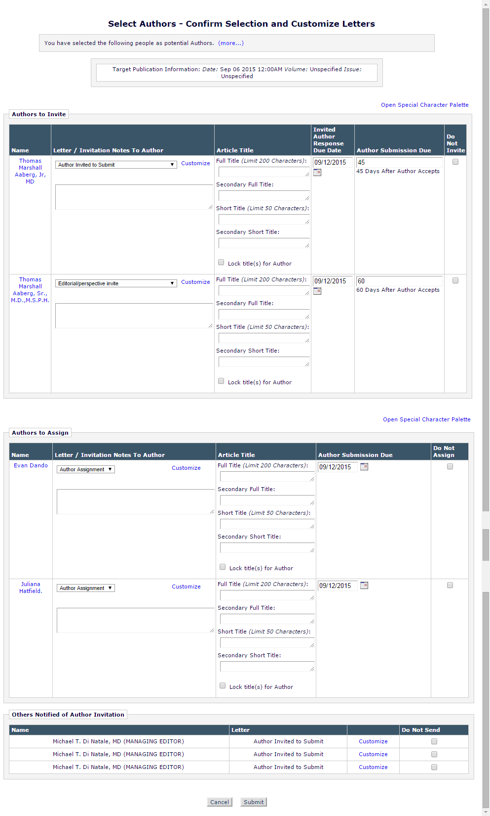

Figure 19: Mocked up Select Authors – Confirm Selection and Customize Letters page showing the page layout when Authors have been selected for assignment only. The Author Invitation Notes and Pre-Defined Article Title features are also enabled.
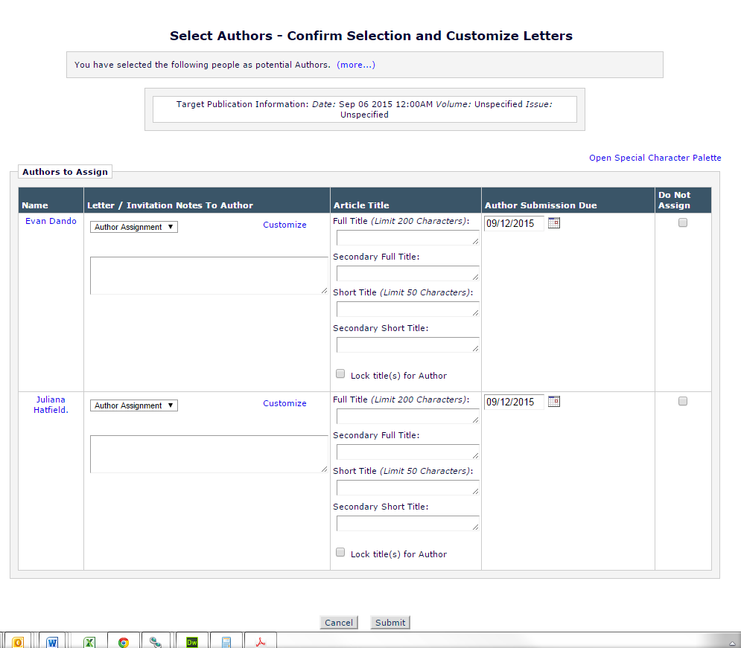

Figure 20: Mocked up Select Authors – Confirm Selection and Customize Letters page showing the page layout when Authors have been selected for invitation only. The Author Invitation Notes and Pre-Defined Article Title features are also enabled.
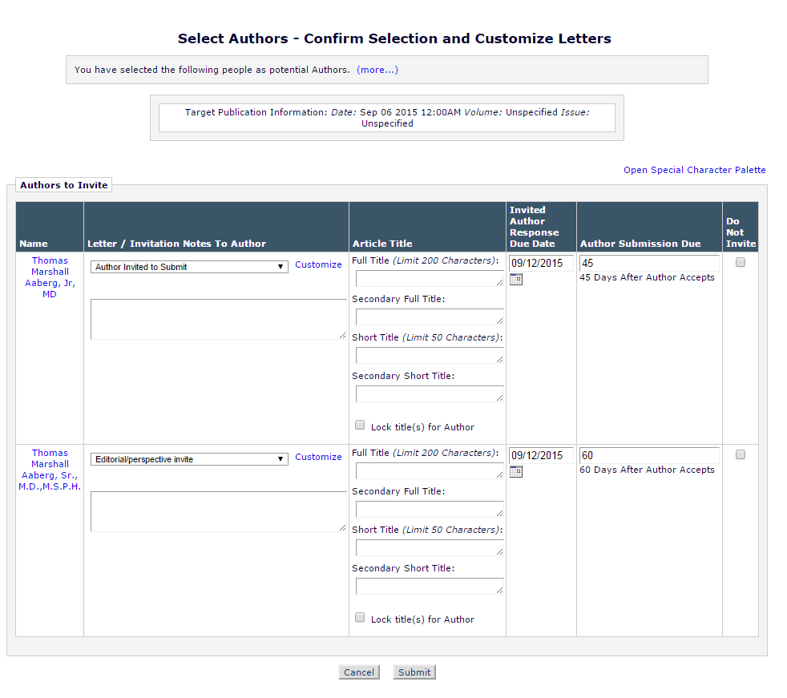

Figure 21: Mocked up Select Authors – Confirm Selection and Customize Letters page showing the page layout when Authors have been selected for assignment only and the Editor does not have the ability to predefine Article Title values. The Invitation Notes to Author feature is enabled.
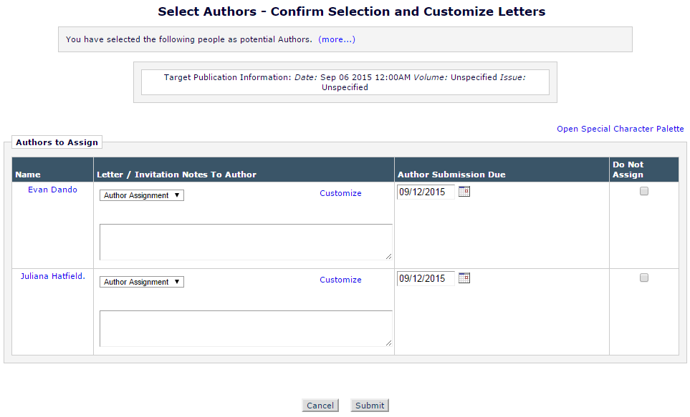

Database tracking of assigned Authors
Under the existing functionality Author invitations are tracked by Editorial Manager using the Invited Authors Table (INVITED_AUTHORS). This separate table is used because records are not placed into the Author Assignment Table (ROLEAUTH) until an Author begins the submission process. This specification introduces the ability to assign Authors directly in a solicited submission workflow. Assigned Authors, like invited Authors, will need to be recorded separately prior to the creation of a record in the Author Assignment Table.

Engineering will determine the best place to store assigned Author records. It is suggested that the following approach be considered:
- Assigned Author records would be added to the existing INVITED_AUTHORS table
  - New column would be added to the existing table to flag items as invitations or assignments
    - This is critical if the assignments are recorded in an existing table because we will need to be able to report on assignments and separate them from invitations
  - Assignment records would co-exist with invitation related fields in the table and new fields would be added as necessary
    - Note: Reviewer Assignments (ROLEREVU) provides an example of this approach as it tracks Reviewer invitations and assignments
      - Table originally held invitation information only
        - When assignment function (9.0-53) was added, ROLEREVU.ASSIGNED_NOT_INVITED was added to mark records which were assignments
    - Under this scenario the existing table fields would be updated as needed when an Author is assigned
- For the purposes of Author statistics assigned authors would be considered as Authors who had agreed to an invitation
  - A detailed accounting of how this data would be record can be found in Section 2.14
- Changes to existing tables or creation of new tables will be fully detailed in the technical spec
  - Users must be able to report on Author assignments as they are currently able to report on Author invitations
  - Users must be able to determine which records were created by assignments and which were created via invitations

Author Invitation Confirmation page [sendMultipleCustomAuthorInvLetters.asp]
The Author Invitation Confirmation page is enhanced by this specification to reflect that authors can now be assigned as well as invited. The page is reached by clicking the [Submit] button found on the Select Authors – Confirm Selections and Customize Letters page.

For all users the page is renamed the Author Selection Confirmation page. This change is reflected in the page title and the header placed on the left-hand side of the page. Additionally the page, which presently displays a list of Author receiving invitations, will be enhanced in order to display a list of Authors who have been assigned. The page will only display lists if relevant to the selections of Authors, meaning that only one or both lists may appear on the page.

New Functionality:
- Author Invitation Confirmation page is enhanced
  - The page title is updated to “Author Selection Confirmation”
  - The header text displayed on left column of page is updated to “Author Selection Confirmation”
- The notification text on the Author Invitation Confirmation page is enhanced
  - When an Author or Authors are invited to submit a message is displayed
    - Message reads, when one Author is selected:
      - “An e-mail has been sent to the following Author notifying them of the invitation:”
    - Message reads, when multiple Authors are selected:
      - “An e-mail has been sent to the following Authors notifying them of the invitation:”
    - The message text is bolded
    - A blank line follows the message text before the selected Author or Authors are listed
      - Each Author appears on a separate line
      - The first, middle, and last name of each selected Author is displayed
    - This section and message is only displayed if Authors are selected for invitation
  - When an Author or Authors are assigned submission a message appears on the now retitled Author Selection Confirmation page
    - Message reads, when one Author is selected:
      - “An e-mail has been sent to the following Author notifying them of the assignment:”
    - Message reads, when multiple Authors are selected:
      - “An e-mail has been sent to the following Authors notifying them of the assignment:”
    - The message text is bolded
    - A blank line follows the message text before the selected Author or Authors are listed
      - Each Author appears on a separate line
      - The first, middle, and last name of each selected Author is displayed
  - This section and message is only displayed if Authors are selected for assignment
When Authors are being invited and assigned both messages are displayed per the requirements outlined under items a and b
    - The invitation message displays first with an empty carriage return appearing before the assignment message is displayed
    - See Figure 22 (below)
  - The navigation links on the page are unchanged

Figure 22: Mockup of enhanced Author Selection Confirmation page now showing Author assignments as well as invitations. Here multiple invitations are sent and the text adjusts by pluralizing Authors. A single assignment is made and this is also reflected in the text.
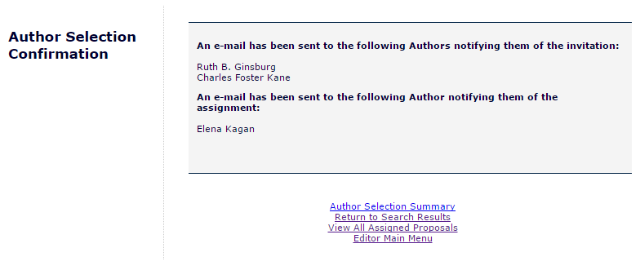

Figure 23: Mockup of enhanced Author Selection Confirmation page now showing Author assignments as well as invitations. Here multiple assignments are sent and the text adjusts by pluralizing Authors. A single invitation is made and this is also reflected in the text.
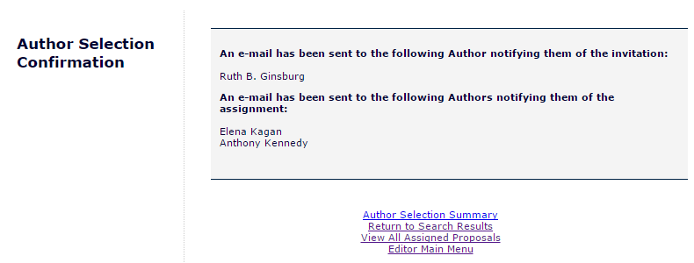

Figure 24: Mockup of enhanced Author Selection Confirmation page. In this example only assignments have been issued.
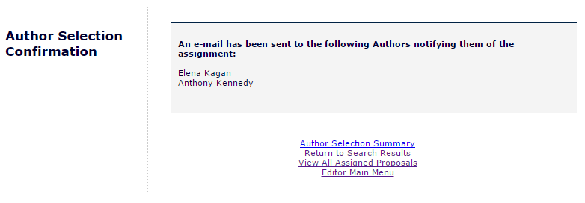

Figure 25: Mockup of enhanced Author Selection Confirmation page. In this example only a single invitation has been issued.
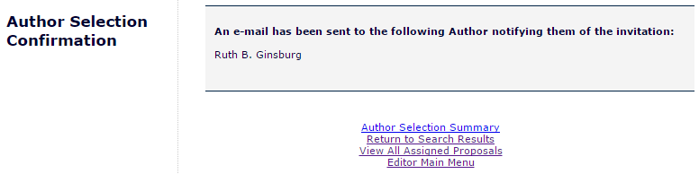

Author Main Menu [AuthorMainMenu.aspx]
The Author Main Menu page is enhanced by this specification such that assignments received by Authors are included and tallied as part of the My Accepted Invitations folder. The folder, and the ‘Invited Submissions’ section of the menu it resides in, will be visible to Authors when they have received an assignment in addition to when they have accepted an invitation, as is the current functionality.

The existing language still applies to a solicited workflow where an assignment takes place instead of an invitation. It may seem out of place in a Books workflow, however language to accommodate that specific use case can be achieved with updates to the books-specific language pack which is being created in concert with this and other books-related Editorial Manager enhancements.

New Functionality:
- The Author Main Menu page is enhanced to accommodate Author assignments
  - The My Accepted Invitations folder will now appear under two circumstances:
    - When an Author has accepted an invitation to submit
    - When an Author has been assigned a paper to submit
      - Note: This will be the first place an assigned submission appears in the interface for an Author
  - Both assigned submissions and accepted invitations will add to the count of submissions displayed for the folder on the menu

Figure 26: The Author Main Menu will not be visually modified by this specification. Assigned submissions will be directed to the My Accepted Invitations folder as they are provided to the Author.
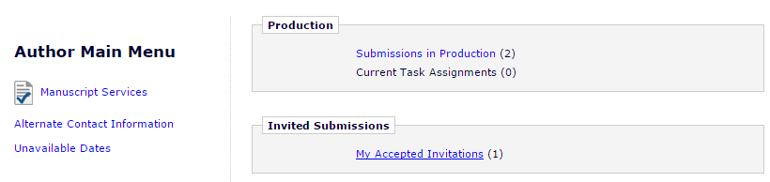

My Accepted Invitations [authorAcceptedInvitations.asp]
The My Accepted Invitations page is accessed from the Author Main Menu by clicking the ‘My Accepted Invitations’ link. The link will be available in the ‘Invited Submissions’ section of the menu when Authors have accepted an invitation or received an assignment

Following the enhancements introduced by this specification, assigned submissions will appear co-mingled with any accepted invitations, similar to how Reviewer assignments are displayed in the Pending Reviewer Assignments folder as established by Spec 9.0-53.

Current functionality:
- Authors Access the My Accepted Invitation page from the Author Main Menu in order to access submissions which they have been solicited to complete
  - Folder is used whether invitations come from a Proposal or as a Solicited Commentary
- Solicited submissions are displayed in the folder by date with the most recent solicitation appear first, at the top of the display grid
- The grid displaying submissions in this folder displays 11 columns, information related to the assignment will be displayed in existing columns as noted below
  - Action
    - Contains all available action links for a submission, including (but not limited to) ‘View Invitation Letter’, ‘View Proposal’, and ‘View Submission Requiring Commentary’
      - ‘View Invitation Letter’ brings up the View Letter page (viewletter.asp) for the invitation letter
      - ‘View Submission Requiring Commentary’ serves as a direct link to the Author/Editor version of the parent submission’s PDF when a commentary is solicited; does not appear for Proposal based solicitations
      - ‘View Proposal’ serves as a direct link to the Author/Editor version of the Proposal’s PDF, if a PDF was built for the Proposal, does not appear for solicited commentaries
  - Manuscript Number
    - Displays the manuscript number of the parent submission from which the invitation originated
  - Article Type
    - Displays the Article Type of the parent submission from which the invitation originated
  - Article Title
    - Displays the Article Title of the parent submission from which the invitation originated
  - Date Author Invited
    - Displays the date, in the publication’s configured format, on which the Author was invited
  - Date Author Accepted
    - Displays the date, in the publication’s configured format, on which the Author accepted the invitation
  - Elapsed Days Since Acceptance Date
    - Displays a count of the number of days since an invitation was accepted
  - Author Submission Due Date
    - Displays the date the submission must be submitted by in order to not be considered late
  - Editor’s Name
    - The name of the Editor who sent the invitation
  - Keywords
    - Keywords representing the parent submission
  - Classification
    - Classification terms selected for the parent submission
- Authors click the ‘Submit Invited Manuscript’ to begin their solicited submission
  - Clicking the link brings the user to the submission interface
- Once an Author has started and saved their solicited submission the submission no longer appears in the My Accepted Invitations folder and will be accessible through the Incomplete Submissions folder in the ‘New Submissions’ section of the Author Main Menu

New functionality:
- The My Accepted Invitation folder is enhanced to include assigned submissions as well as submissions with accepted invitations in order to access submissions which they have been solicited to complete
  - Folder used whether solicited submissions come from a Proposal or as a Solicited Commentary
- Solicited submissions are displayed in the folder by date with the most recent solicitation appearing first, at the top of the display grid
- For only assigned submissions a new View Assignment Letter Action Link is available
  - Clicking the link ‘View Assignment Letter’ brings up the View Letter page (viewletter.asp) for the assignment letter sent to the Author when the new ‘Author Assigned (Not Invited) for Proposal’ or ‘Author Assigned (Not Invited) for Commentary’ events is triggered depending on the type of invited workflow being used
- The View Invitation Action Link is not available for assigned submissions
  - It remains available for invited submissions
- The grid displaying submissions in this folder displays 11 columns
  - Action
    - Contains all available Action Links for a submission, when appropriate including (but not limited to) View Assignment Letter, View Invitation Letter, Submit Invited Manuscript, View Proposal, and View Submission Requiring Commentary Action Links
      - View Assignment Letter brings up the View Letter page (viewletter.asp) for the assignment letter for submissions where an Author was directly assigned
      - View Invitation Letter brings up the View Letter page (viewletter.asp) for the invitation letter for invited submissions where the Author has accepted the invitation
      - Submit Invited Manuscript allows the Author to start their invited or assigned solicited submission
      - ‘View Proposal’ serves as a direct link to the Author/Editor version of the Proposal’s PDF, if a PDF was built for the Proposal, does not appear for solicited commentaries
      - View Submission Requiring Commentary serves as a direct link to the Author/Editor version of the parent submission’s PDF when a commentary is solicited; does not appear for Proposal based solicitations
    - All Action links appearing in this folder currently should continue to appear using the same logic, unless otherwise noted above
  - Manuscript Number
    - Displays the manuscript number of the parent submission from which the invitation originated
  - Article Type
    - Displays the Article Type of the parent submission from which the invitation originated
  - Article Title
    - Displays the Article Title of the parent submission from which the invitation originated
  - Date Author Invited
    - For accepted invitations: Displays the date, in the publication’s configured format, on which the Author was invited
    - For assigned submissions: Displays the date, in the publication’s configured format, on which the Author was assigned
  - Date Author Accepted
    - For accepted invitations: Displays the date, in the publication’s configured format, on which the Author accepted the invitation
    - For assigned submissions: Displays the date, in the publication’s configured format, on which the Author was assigned
  - Elapsed Days Since Acceptance Date
    - For accepted invitations: Displays a count of the number of days since an invitation was accepted
    - For assigned submissions: Displays a count of the number of days since an Author was assigned
      - Note: Since an assignment is recorded as an accepted invitation new logic may not be necessary to make this calculation
  - Author Submission Due Date
    - Displays the date the submission must be submitted by in order to not be considered late
  - Editor’s Name
    - The full name and degree of the Editor who sent the invitation
  - Keywords
    - Keywords associated the parent submission
  - Classification
    - This column’s label is enhanced, and will now read “Classifications”
    - Classification terms selected for the parent submission
- Authors click the Submit Invited Manuscript Action Link to begin their solicited submission
  - Clicking the link brings the user to the submission interface
  - Used for invited and assigned solicited submissions
- Once an Author has started and saved their solicited submission the submission no longer appears in the My Accepted Invitations folder and will be accessible through the Incomplete Submissions folder in the ‘New Submissions’ section of the Author Main Menu

Figure: Mocked up image of the My Accepted Invitations folder. Here an assigned paper (highlighted with a red box) is co-mingled with an accepted invitation. The assignment is noted visually by the inclusion of a ‘View Assignment Letter’ action link.
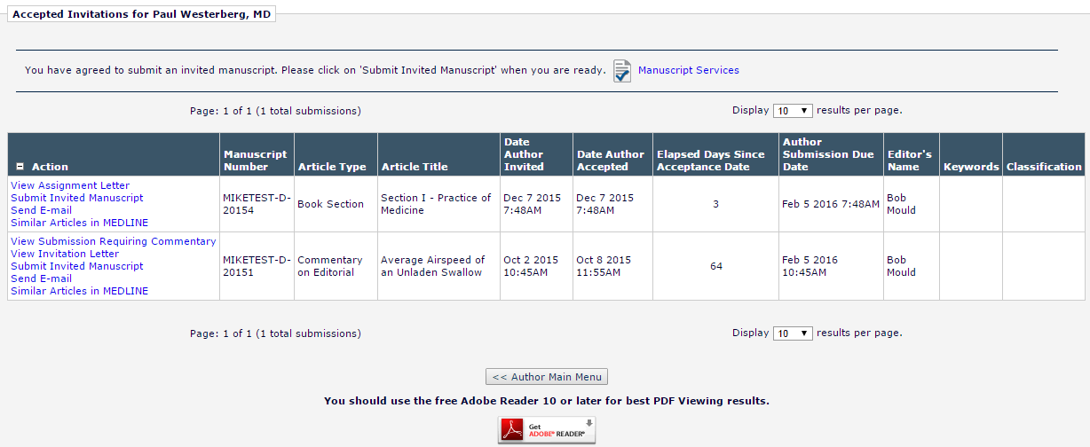

Author Statistics
This section assumes Engineering has decided to record incoming Author assignments in the Invited Authors Table, as suggested in Section 2.10.1. This suggestion includes adding a field to the Invited Authors Table to flag records as assignments. If that is not the case this section will be rewritten as needed.

There are two tables used to accumulate Author statistical data. A full detail account of updating these tables must be in the technical spec. Business logic is described below:
- Invited Authors Table [INVITED_AUTHORS]
- Author Invitation Statistics Table [AUTHOR_INVITATION_STATS]

These tables are currently updated when Authors are invited to submit and while the invitation goes through the process of being accepted.

Table 1: The Invited Authors Table is updated as follows when an Author is assigned.
Field Name | Field Location | Action
Unique identifier for this table | INVITED_AUTHORS_ID | ID created for record per existing functionality
Author Accept Date | ACCEPT_DATE | Populated with the date/time that corresponds with the moment of assignment
LetterID for the invitation letter | AUTHOR_INV_LETTER_CORR_HIST_ID | Populated with the Letter ID for the letter sent at assignment to the Author
Date Invited Submission Received | COMPLETE_DATE | Not populated at assignment per existing functionality
Author Completed | COMPLETED | Populated with a value of 0 per existing functionality
Number of days for Author response | DAYS_TO_RESPOND | Not populated when assignment used
Reason for Decline | DECLINE_COMMENTS | Not populated when assignment used
Author Accepted Invitation | WORK_IN_PROGRESS | Populated with a value of 1 indicating the assignment was accepted
Date Author Invited | [INVITATION_DATE] | Populated with the date/time that corresponds with the moment of assignment
Invitation Response Due Date | INVITATION_RESPONSE_DUE_DATE | Not populated when assignment used
Date Last Invitation Reminder Sent | LAST_REMIND_DATE | Not initially populated per existing functionality
Number of Invitation Reminders Sent | REMIND_COUNT | Not initially populated per existing functionality
Author Has Not Responded | HAS_NOT_RESPONDED | This is a bit field which indicates whether an Author has responded to invitation or not. A value of 1 means that the Author responded to invitation and a value of 0 means the Author has not responded to invitation. Assignments are treated as accepted invitations, thus the field is populated with a value of 1 indicating the Author has responded
Author Declined Invitation | DECLINED | Populated with a value of 0
Author Uninvited | UNINVITED | Populated with a value of 0
Date Author Declined Invitation | DECLINE_DATE | Not initially populated
Parent Document ID generating the invitation | DOCUMENTID | Populated with DocID of the parent submission from which the assignment originates
Revision Number | REVISION | Records the revision number of the parent submission at the time of the invitation, when soliciting via Proposals the value is always populated with a value of 0.
Last Update Date | LASTUPDATE | Populated with the date and time of the last update to the record
People ID | PEOPLEID | People ID of the assigned Author
Author Submission Due Date | SUBMISSION_DUE_DATE | Populated with the due date of the solicited submission
Date Author Uninvited | UNINVITE_DATE | Not initially populated per existing functionality
Inviting Editor ID | INVITED_BY | Populated with the people ID of the Editor who invited the Author
Old Inviting Editor ID | OLD_INVITED_BY | Not initially populated per existing functionality
Old People ID | OLD_PEOPLEID | Not initially populated per existing functionality
Last modified DateTime | ROW_LASTMODIFED_TIMESTAMP | Populated with the date and time of the last update to the record
Submissions available to Invited Authors | AUTH_LINKED_DOCS | This is an XML list of submissions. The invited author is given access to the reviewer version of the PDF of these submissions.
ID of the document produced for invitation | CHILD_DOCUMENTID | Not initially populated per existing functionality
Alternate author's rank | ALTERNATE_RANK | NULL value entered
Associated Event Letter ID | EVENT_LETTER_ID | Populated per existing functionality -  This is the ID of a MULTIPLELETTERS entry associated with this solicitation. Tracking assignment letters may require some code changes
Days to submit invited manuscript | DAYS_TO_SUBMIT | Populated used Article Settings per existing functionality
Invitation Notes to Author | INVITED_AUTHOR_NOTES | Populated per existing functionality
Submission Due Date Calculation Type | SUB_DUE_DATE_TYPE | Populated per existing functionality

Table 2: Several fields in the Invited Authors Table are updated when an assigned Author is unassigned via the ‘Un-assign’ link on the Author Selection Summary page. These updates are documented below. All other fields are updated per current coding.
Field Name | Field Location | Action
Author Uninvited | UNINVITED | Populated with a value of 1
Last Update Date | LASTUPDATE | Populated with the date and time of the last update to the record
Date Author Uninvited | UNINVITE_DATE | Populated with the Data/Time at which the Author was uninvited
Last modified DateTime | ROW_LASTMODIFED_TIMESTAMP | Populated with the date and time of the last update to the record

Table 3: Several fields in the Authors Invitation Statistics Table are updated when an Author is assigned a submission. The intention is to treat assigned submissions as accepted invitations when tracking them for statistical purposes.
Field Name | Field | Action
Author Invitation Stats ID | AUTHOR_INVITATION_STATS_ID | ID created for record per existing functionality
People Unique ID | PEOPLE_ID | People ID of the author to which these stats are related
Invited Submissions in Progress | INVITED_SUBMISSIONS_IN_PROGRESS | Counts the number of solicited submissions in process with an Author prior to submission. An assigned submission would increase this number
Invitations Outstanding | INVITATIONS_OUTSTANDING | Not impacted by Author assignments
Total Invitations | TOTAL_INVITATIONS | The total number of invitations sent to an author. It is the sum of Invitations Outstanding, Accepted Invitations, Declined Invitations and Uninvited Before Responding. Since assignments are treated as accepted invitations, this calculation would increase each time an assignment is made
Accepted Invitations | ACCEPTED_INVITATIONS | Increased each time an Author is assigned
Declined Invitations | DECLINED_INVITATIONS | Not impacted by Author assignments
Uninvited Before Responding | UNINVITED_PRIOR_TO_RESPONDING | Not impacted by Author assignments
Uninvited After Accepting | UNINVITED_AFTER_ACCEPTING | Increased when an Author is uninvited following an assignment
Invited Submissions Completed | COMPLETED_INVITATIONS | Increased when an Author submits an assigned submission
Completed On Time | COMPLETED_ON_TIME | Calculation will include assigned submissions
Completed Late | COMPLETED_LATE | Calculation will include assigned submissions
Average Days to Respond | AVERAGE_DAYS_TO_RESPOND | Calculation would not include for records where the associated Author was assigned
Average Days to Complete | AVERAGE_DAYS_TO_COMPLETE | Calculation will include assigned submissions
Average Days Completed Late | AVERAGE_DAYS_COMPLETED_LATE | Calculation will include assigned submissions
Average Reminder Count | AVERAGE_REMINDER_COUNT | Calculation will include assigned submissions
Date Last Accepted | DATE_LAST_ACCEPTED | Will be updated when an Author is assigned
Date Last Declined | DATE_LAST_DECLINED | Not impacted by Author assignments
Date Last Completed | DATE_LAST_COMPLETED | Will be updated when an Author assignment is submitted
Last modified DateTime | ROW_LASTMODIFED_TIMESTAMP | Will be updated when changes made to record are caused by assignments
Date Last Invited | DATE_LAST_INVITED | Will be updated when an Author is assigned and be displayed in the interface as the date an Author was last invited

Database Impact
To be detailed in the technical spec, suggestions below:
- A new ‘Author Assigned’ Boolean/status field is added to the Invited Authors Table [INVITED_AUTHORS] to track whether assignments were invited or assigned
- A new field is added to the Editor Role Table [EDITORROLE] for the new ‘Assign Authors (without Invitation)’ permission.
- Two new events added to the Event List table [EVENT]. This table holds ActionManager Events
- Letter Assignment Table [LETTERS] – New Event ID added (tables linking each ActionManager event to the appropriate letter ID for each Role).

DB Content Changes

UDB Impact
Considerations: Do new fields need UDB-Only DB Content?

Multi-Lingual Considerations

Performance Processing Impact
Loading of search results pages with the new selection options should not add significant load times to the pages.

Selecting users for assignment should not add significant loading to the sending of letters to Authors.

Adding a check to processing of the Author List File (ALF) to determine which selection option to preselect should not add significant processing times to the handling of the ALF file.

Performance Requirements

Data Server

Web Server

Network

Client Machine

Engineering Assessment

Engineering Test Results

Merge Field Impact

Upgrade Script Impact
If the suggested field for noting that an Author is assigned is added to the INVITED_AUTHORS table, Engineering will determine if a script will be needed to update existing records in INVITED_AUTHORS with a value for the new database field or if users can assume that if the new field is null, the Author was invited.

Site Cleanout

Report Implications
It is suggested that a new bit field be added to INVITED_AUTHORS to indicate that the Author was assigned. If implemented, this field must be designated as “Active” in DBCONTENT, resulting in its appearance in General Data Export and Enterprise Analytics Reporting by default.

A new permission bit field is added to EDITORROLE. This bit field is designated as “Active” in DBCONTENT, resulting in its appearance in General Data Export and Enterprise Analytics Reporting by default.

This section will be updated upon completion of the technical spec so that the final design is represented.

Canned Reports

Co-Author Reminder Report
No change needed. Invitation and assignment data not present in report. Testing must ensure the co-authors tied to Authors who have been assigned appear properly in the report results.

Author Revision Status Report
No change needed. Invitation and assignment data not present in report. Testing must ensure the assigned Authors appear properly in the report results.

Author Revision Reminder Report
No change needed. Invitation and assignment data not present in report. Testing must ensure the assigned Authors appear properly in the report results.

Automated Author Revision Reminder Report
No change needed. Invitation and assignment data not present in report. Testing must ensure the assigned Authors appear properly in the report results.

Automated Author Transfer Reminder Report
No change needed. Invitation and assignment data not present in report. Testing must ensure the assigned Authors appear properly in the report results.

Proposal Pipeline Report
No changes to report coding are necessary if assignment data is captured in the INVITED_AUTHORS table. If existing table is used the Date Author Invited, Date Author Agreed, Date Author Declined and Date Author Invited fields in the result will reflect the values for assignments as detailed by Section 2.10.1. Assignments would be clearly identifiable in the results set because the Date Author Invited would be NULL while the Date Author Agreed would be populated with the assignment date. Testing must ensure the assigned Authors appear properly in the report results.

Authors Invited – No Response
No change needed. This report is focused on invited submissions where the Author has not yet agreed. Assigned Authors are treated as Authors who have agreed and thus have no place in the results generated by this report.

Author Invitation Status Report
No changes to report coding are necessary if assignment data is captured in the INVITED_AUTHORS table per recommendation. Assigned Authors would be treated as Authors who accepted an invitation to submit and would appear in the report’s results when the established criteria matched as assignment data is stored per Section 2.10.1.

General Data Export
It is suggested that a new bit field be added to INVITED_AUTHORS to indicate that the Author was assigned. If implemented, this field must be designated as “Active” in DBCONTENT, resulting in its appearance in General Data Export and Enterprise Analytics Reporting by default.

A new permission bit field is added to EDITORROLE. This bit field is designated as “Active” in DBCONTENT, resulting in its appearance in General Data Export.

Two new events are added to EVENT. The new event must be available in General Data Export.

Custom Reports
It is suggested in Section 2.10.1 that a new bit field be added to INVITED_AUTHORS to indicate that the Author was assigned. If implemented, this field must be added to the Authors & Submissions View (ROLEAUTH_DOC_PEOPLE_ADDR).
- The new bit field is added after the existing Parent Manuscript Number (ROLEAUTH_DOC_PEOPLE_ADDR.PARENT_MS_NUM)
- As with other fields, it is available as a selection criterion and in the report results

Figure: Partial view of the updated ROLEAUTH_DOC_PEOPLE_ADDR view in Custom Reports showing the new field as selectable. Image is cropped to display new option and does not display all available fields.
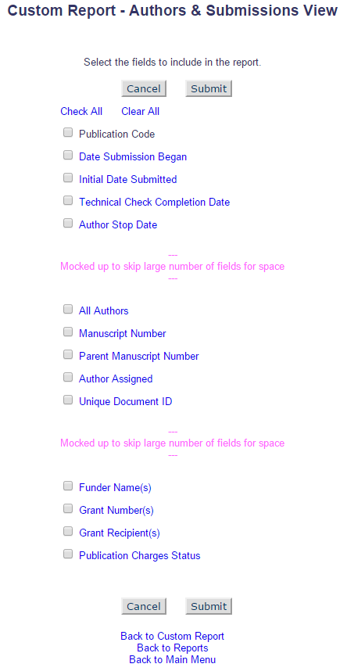

Enterprise Analytics Reporting
It is suggested in Section 2.10.1 that a new bit field be added to INVITED_AUTHORS to indicate that the Author was assigned. This table is already included in EAR and is available from the Data Sources tab. If the new field is implemented as suggested it must be available in EAR. Additionally, if implemented, this field must be added to the Authors & Submissions View (ROLEAUTH_DOC_PEOPLE_ADDR) where it is available as a data source in EAR.

A new permission bit field is added to EDITORROLE. This bit field is designated as “Active” in DBCONTENT, resulting in its appearance in Enterprise Analytics Reporting as part of the Editor Role Table.

Cross-Publication EAR
It is suggested in Section 2.10.1 that a new bit field be added to INVITED_AUTHORS to indicate that the Author was assigned, if that table is used to hold Author assignments. If the new field is implemented as suggested it must be added to the Cross-Publication Authors & Submissions View (ROLEAUTH_DOC_PEOPLE_ADDR). This will allow publishers to identify assigned authors across multiple sites.

Hosting Documentation Impact

Portal (IJRS, etc.) Impact
The Authors Results pages show a “Last Invited Submission Agreed” stat. This is a date representing the last time an Author was invited. Under this specification this date is updated when an Author is assigned. This is also visible “Portal-wide” per spec 10.0-62 for sites which share People Information. The impact of the assign functionality updating the value must be considered an impact on the Portal functionality.

Hosting Administration Impact

Hosting Administration Audit Trail
Any changes made to any Hosting Administration code should include invocation of the HA Audit Trail code module to ensure that appropriate data about administration changes are recorded to the HA Audit Trail

Sys Admin Audit Trail
Any changes made to the PolicyManager, RoleManager, ActionManager and AdminManager code should include invocation of the Audit Trail code module to ensure that appropriate data about administration changes are recorded to the Audit Trail.

Import/Export Impact
Should consist of elements/data 1) that would need to be added to the generic Aries Export schema/XML and/or 2) available for Aries import and added to the “Select Fields for Import” page and Aries Import schema and script.

Transmittal Impact

Aries Export Impact

Aries Import Impact

Transfer Impact

Cross-Publication Impact
Anything not covered in the reporting section (i.e. journal acronym change, cross-pub login, consideration for additional use cases, etc.)

Documentation and Training

Operations’ Considerations

Journal Rename

Journal Redirects

Utilities
Consider any or all of the following with Engineering consultation:
- UDB Utility
- Upgrader
- IJRS Sync Tool
- Deleter
- Cloner
- Migrator
- Translation Utility

Audit/Monitor/Diagnostics
Used when going out to a 3rd party system to detect if the system is up. Add to an existing “Tembria dashboard”; indicate who should get e-mail notices if 3rd party goes down.

Journal Configuration
The ability to Assign Authors is available to Editors who have been configured with the new RoleManager permission, ‘Assign Authors (Commentaries/Proposals’. Once the permission is enabled Editors will be able to select an assignment checkbox when searching for Authors by name or classification matches.

Three related ActionManager events must be configured with letter templates in order to ensure that proper notifications are sent to Authors as they are assigned and unassigned. These events are:
- ‘Author Assigned (Not Invited) for Proposal’
  - Triggered when an Author is assigned via a Proposal
- ‘Author Assigned (Not Invited) for Commentary’
  - Triggered when an Author is assigned via Solicit Commentary
- ‘Author Unassigned’
  - Triggered when an Author is unassigned

No configuration is necessary to select Authors for assignment when selecting Authors using an uploaded Author List File (ALF). The assignment option will also be available to Editors who have uploaded and ALF.

Style Sheet impact

Deployment Considerations

Associated Revenue Model

Sales and Marketing Rollout Anticipation

Customer Service Rollout Preparation

Release Target
This specification is developed for 13.1

Future Development
Future development may require additional changes to the AUTHOR_INVITATION_STATS table in order to further separate out tracking of assignments versus invitations.

Mobile Considerations
Functional considerations for smartphones and tablets (if applicable)

Use Cases and Test Scenarios
Test cases will be added prior to management approval.

Regression Test Cases

Specification Test Cases
- Confirm new ‘Assign Authors (without Invitation)’ permission is available in RoleManager for Editors
  - As an administrator log into EM
  - Go to System Administrator Functions and select RoleManager
  - Click the ‘Editor Role’ link and then click the [Add] button to open a new RoleManager configuration page
  - Scroll to the Proposals and Commentaries section and confirm that the new ‘Assign Authors (without Invitation)’ is present, displayed immediately before the ‘Lock/Unlock Predefined Article Title’ permission
  - Confirm that the permission can be selected and unselected
  - Confirm that the permission can be selected and unselected independently of the existing ‘Invite Authors/Solicit Commentaries’ permission
  - Confirm that the permission remains selected once saved as selected
  - Confirm that the permission remains deselected once saved as deselected
- Confirm that the four new ActionManager events implemented in this specification are present when configuring a user role, that initially no letter is selected each new event, and that for each a letter can be selected
  - As an administrator log into EM
  - Go to System Administrator Functions and select ActionManager
    - Confirm that the following new events are present in the Author Invitation section when configuring user roles:
      - ‘Author Assigned (Not Invited) for Proposal’
        - Displayed following ‘Invite Authors for Proposal’
      - ‘Author Assigned (Not Invited) for Commentary’
        - Displayed following ‘Solicit Commentary on Submission’
      - ‘Author Unassigned after Accepting Invitation’
        - Displayed following ‘Un-invite Authors’
      - ‘Author Unassigned after Assignment’
        - Displayed following ‘Author Unassigned after Accepting Invitation’
    - Confirm that initially no letters are selected for these events
    - Confirm that users can select letters for the events
    - Confirm that once selected the selections can be saved
- Confirm that new ActionManager events are present when configuring Document Status, confirm that initially no new document status is selected
  - As an administrator log into EM
  - Go to System Administrator Functions and select ActionManager
    - Confirm that the following new events are present in the Author Invitation section when configuring Document Status:
      - ‘Author Assigned (Not Invited) for Proposal’
        - Displayed following ‘Invite Authors for Proposal’
      - ‘Author Assigned (Not Invited) for Commentary’
        - Displayed following ‘Solicit Commentary on Submission’
      - ‘Author Unassigned after Accepting Invitation’
        - Displayed following ‘Un-invite Authors’
      - ‘Author Unassigned after Assignment’
        - Displayed following ‘Author Unassigned after Accepting Invitation’
    - Confirm that initially no letters are selected for these events
  - Confirm that ‘Author Assigned (Not Invited) for Proposal’ can have a status selected
    - Confirm that once selected the selection can be saved and changed
  - Confirm that the remaining three events cannot
- Confirm the ‘Upload Author List’ tool tip on the Author Selection Summary page is updated with the new text presented in this specification
  - Log into a test site using an Editor who has either the new ‘Assign Authors (without Invitation)’ permission, the ‘Invite Authors/Solicit Commentaries’ permission or both
  - Go to the Author Selection Summary page either via the Solicit Commentary Action Link for a submission or the Invite Authors Action Link available for a Proposal
    - On the Author Selection Summary page select ‘Upload Author List’ from the Search My Publication drop-own menu
    - Confirm that the blue and white “i” icon appears to the right of the menu when the ‘Upload Author List’ option is selected
    - Confirm that hovering over the icon produces an expandable tool tip
      - Expand the tool tip and confirm that the following text is displayed (as indicated by Section 2.3):

Use this option to upload a list of potential Authors from a file which includes their First Name, Last Name, Email Address, and optionally, a description of the material they will be asked to author and an ORCID iD.

To upload a file of people to invite as Authors, you can either click the 'Choose File' button to browse your computer, or drag and drop a file onto the folder image below. Only a single file may be selected at a time.

Caution: The file must be in one of the following formats:
- Comma Separated Value (*.csv, *.txt)
- Tab Delimited File (*.tab, *.txt)

The first row must be a header with three to seven columns:
Required:
- FIRSTNAME
- LASTNAME
- EMAIL
Optional:
- INVITE
- TITLE
- NOTE
- ORCID

Information for each potential Author should be entered on a separate row. Each row included represents a separate invitation and Authors receiving multiple invitations appear in multiple rows. You may enter multiple email addresses separated by semi-colons.

INVITE is a true/false field which will determine how an Author is selected by default when the list is imported. When set to TRUE an Author is selected for invitation, when FALSE for assignment, and if no value is provided no selection is made.

Example:
INVITE | FIRSTNAME | LASTNAME | EMAIL | ORCID | TITLE | NOTE
TRUE | Mary | Smith | ms@email.com | XXXX-XXXX-XXXX-XXXX | Chapter 1 | Loremipsum

The system will attempt to match up each Author with a registered user in the system. If the Author is not registered and that Author is invited to submit, the system will proxy-register the Author before sending them the invitation.

- Confirm enhanced instructions display when choosing to search for Authors from the Author Selection Summary page
  - Log into the test site as an Editor with the new ‘Assign Authors (without Invitation)’ permission, the ‘Invite Authors/Solicit Commentaries’ permission or both enabled
  - Go to the Author Selection Summary page either via the Solicit Commentary Action Link for a submission or the Invite Authors Action Link available for a Proposal
    - On the Author Selection Summary page select ‘Search for Authors’ from the Search My Publication drop-down menu in order to test the Search for Authors by Name Results page
    - Click the [Go] button
    - You’ll now be able to search for an Author, enter criteria which will produce results
    - When the ‘Author Candidates’ grid appear confirm that the updates instructions are displayed:
      - The new text is inserted into the existing grey box
      - The new instructional text is expandable,
      - The text initially appears as collapsed when search results are loaded
        - The collapsed text includes a portion of the full text followed by a “(more…)” link
        - The collapsed text reads: “Select a checkbox fir each person you wish to select as an Author”
        - When the “(more…)” link is clicked the grey box is expanded to show the full text
          - When expanded the “(more...)” link becomes a “(less…)” link
          - Additional text is displayed: “Depending on your permissions, you may select Authors to be Invited ("Inv.") or Assigned ("Asn."). Your selection may vary Author to Author, but each individual may only be selected for invitation or assignment. Your selections will be retained when you change to a different results page or change the search.”
          - When the “(less…)” link is clicked the grey box returns to its initial state and the additional text is hidden
  - Repeat the above steps but instead select ‘Search by Personal Classifications’ from the search drop-down menu in order to test the Search for Authors by Personal Classifications Results page
  - Confirm the instructions appear on both pages regardless of whether an Editor has the new ‘Assign Authors (without Invitation)’ permission, the ‘Invite Authors/Solicit Commentaries’ permission or both enabled
- Confirm the UI enhancements to the Author search results pages (Search for Authors by Personal Classifications Results page and Search for Authors by Name Results page) when the ‘Assign Authors (without Invitation)’ permission and the ‘Invite Authors/Solicit Commentaries’ permissions are enabled
  - Log into the test site as an Editor with both the new ‘Assign Authors (without Invitation)’ permission and the ‘Invite Authors/Solicit Commentaries’ permission enabled
    - Go to the Author Selection Summary page either via the Solicit Commentary Action Link for a submission or the Invite Authors Action Link available for a Proposal
      - On the Author Selection Summary page select ‘Search for Authors’ from the Search My Publication drop-down menu in order to test the Search for Authors by Name Results page
      - Click the [Go] button
      - You’ll now be able to search for an Author, enter criteria which will produce results
    - The ‘Author Candidates’ grid is enhanced
      - Confirm that the former ‘Number of Invitation Letters’ column header is relabelled ‘Number of Letters’
      - Confirm that the ‘Select’ column is relabelled ‘Select As’
        - Confirm that the cell below is split and displaying a column labelled “Inv.” on the left and a column labelled “Asn.” on the right
        - Confirm selection labels are formatted as headers with white, bold text against an EM blue background
        - Confirm that a checkbox appears centered in each column for each user in the search result
        - Confirm that only one of the check boxes can be selected for each user record in the result
        - Confirm that selecting one option for a user will unselect the other, if it is already selected
        - Confirm that different checkbox selection between separate user accounts in the result set is allowed
    - Repeat the above steps but instead select ‘Search by Personal Classifications’ from the search drop-down menu in order to test the Search for Authors by Personal Classifications Results page
- Confirm the UI enhancements to the Author search results pages (Search for Authors by Personal Classifications Results page and Search for Authors by Name Results page) when the ‘Assign Authors (without Invitation)’ permission is enabled
  - Log into the test site as an Editor with only the new ‘Assign Authors (without Invitation)’ permission enabled
    - Go to the Author Selection Summary page either via the Solicit Commentary Action Link for a submission or the Invite Authors Action Link available for a Proposal
      - On the Author Selection Summary page select ‘Search for Authors’ from the Search My Publication drop-down menu in order to test the Search for Authors by Name Results page
      - Click the [Go] button
      - You’ll now be able to search for an Author, enter criteria which will produce results
    - The ‘Author Candidates’ grid is enhanced
      - Confirm that the former ‘Number of Invitation Letters’ column header is relabelled ‘Number of Letters’
      - Confirm that the selection column is labelled ‘Select’
        - Confirm that the cell below ‘Select’ in the grid heads a single column labelled “Asn.”
          - Confirm “Asn.” label is formatted as a header with white, bold text against an EM blue background
        - Confirm that a checkbox appears centered in the column for each user in the search result
        - Confirm that the check box can be selected and unselected
    - Repeat the above steps but instead select ‘Search by Personal Classifications’ from the search drop-down menu in order to test the Search for Authors by Personal Classifications Results page
- Confirm the UI enhancements to the Author search results pages (Search for Authors by Personal Classifications Results page and Search for Authors by Name Results page) when the ‘Invite Authors/Solicit Commentaries’ permission is enabled
  - Log into the test site as an Editor with only the ‘Invite Authors/Solicit Commentaries’ permission enabled
    - Go to the Author Selection Summary page either via the Solicit Commentary Action Link for a submission or the Invite Authors Action Link available for a Proposal
      - On the Author Selection Summary page select ‘Search for Authors’ from the Search My Publication drop-down menu in order to test the Search for Authors by Name Results page
      - Click the [Go] button
      - You’ll now be able to search for an Author, enter criteria which will produce results
    - The ‘Author Candidates’ grid is enhanced
      - Confirm that the former ‘Number of Invitation Letters’ column header is relabelled ‘Number of Letters’
      - Confirm that the selection column is labelled ‘Select’
        - Confirm that the cell below ‘Select’ in the grid heads a single column labelled “Inv.”
          - Confirm “Inv.” label is formatted as a header with white, bold text against an EM blue background
        - Confirm that a checkbox appears centered in the column for each user in the search result
        - Confirm that the check box can be selected and unselected
    - Repeat the above steps but instead select ‘Search by Personal Classifications’ from the search drop-down menu in order to test the Search for Authors by Personal Classifications Results page
- Confirm that assignment of Authors takes place when Authors are selected using the new assignment option when inviting Author using a Proposal
  - Log into the test site as an Editor with the new ‘Assign Authors (without Invitation)’ permission enabled and the ‘Invite Authors/Solicit Commentaries’ permission not enabled
    - Go to the Author Selection Summary page either via the Invite Authors Action Link available for a Proposal
      - On the Author Selection Summary page select ‘Search for Authors’ from the Search My Publication drop-down menu in order to test the Search for Authors by Name Results page
      - Click the [Go] button
      - You’ll now be able to search for an Author, enter criteria which will produce results
    - In the ‘Author Candidates’ grid
      - Select a “Asn.” check box for an Author and then click the [Proceed] button
      - You will be brought to the ‘Select Author – Confirm Selection and Customize Letter page
        - Confirm that the default letter selected for the Author’s notification is the letter associated with the ‘Author Assigned (Not Invited) for Proposal’ ActionManager event
        - Proceed
          - Confirm that the Author Invitation Confirmation page is displayed
          - Confirmed that the Author Invitation Confirmation page title and header are updated to “Author Selection Confirmation”

        - Confirm the letter was sent to the Author
    - Log in as the Author

    - Repeat the above steps but instead select ‘Search by Personal Classifications’ from the search drop-down menu in order to test the Search for Authors by Personal Classifications Results page

- Confirm that Author Selection Summary page is updated such that the ‘Selected Authors’ grid reflects the new assignment and unassignment statuses which have been added
  - Log into the test site as an Editor with both the new ‘Assign Authors (without Invitation)’ permission and the ‘Invite Authors/Solicit Commentaries’ permission enabled
    - Go to the Author Selection Summary page either via the Solicit Commentary Action Link for a submission or the Invite Authors Action Link available for a Proposal
      - For the test paper invite and assign a mix of Authors, these Authors will be made to accept, decline, not response, be invited, and unassigned in order to test the Author invitation statuses and availability of links on the page
      - Within the ‘Selected Author’ grid:
        - When an Author has submitted their invited submission, confirm:
          - The Author name is displayed as a link to their People Information page
          - A status of ‘Author Complete’ is displayed followed by the date of submission in green text
          - A ‘View Letter’ link is displayed which links to the invitation letter sent to the Author
        - When an Author has submitted their assigned submission, confirm:
          - The Author name is displayed as a link to their People Information page
          - A status of ‘Author Complete’ is displayed followed by the date of submission in green text
          - A ‘View Letter’ link is displayed which links to the assignment letter sent to the Author
        - When an Author has agreed to an submit after receiving an invitation, confirm:
          - The Author name is displayed as a link to their People Information page
          - A status of ‘Agreed to Submit’ is displayed followed by the date the Author agreed in orange
          - A ‘View Letter’ link is displayed which links to the invitation letter sent to the Author
          - An ‘Un-assign’ link is available to uninvite the Author
        - When an Author has been assigned, confirm:
          - The Author name is displayed as a link to their People Information page
          - A status of ‘Author Assigned’ is displayed followed by the date the Author was assigned in orange
          - A ‘View Letter’ link is displayed which links to the assignment letter sent to the Author
          - An ‘Un-assign’ link is available to uninvite the Author
        - When an Author has been invited, confirm:
          - The Author name is displayed as a link to their People Information page
          - A status of ‘Author Invited’ is displayed followed by the Date of the invitation in red
          - A ‘View Letter’ link is displayed which links to the invitation letter sent to the Author
          - An ‘Un-invite’ link is available to uninvite the Author
        - When an Author has declined, confirm:
          - The Author name is displayed as a link to their People Information page
          - A status of ‘Author Declined’ is displayed followed by the date of the decline in black
          - A ‘View Letter’ link is displayed which links to the invitation letter sent to the Author
        - When an Author has been uninvited, confirm:
          - The Author name is displayed as a link to their People Information page
          - A status of ‘Author Un-invited’ is displayed followed by the uninvited date in black
          - A ‘View Letter’ link is displayed which links to the invitation letter sent to the Author
        - When an Author has been unassigned after agreeing to an invitation, confirm:
          - The Author name is displayed as a link to their People Information page
          - A status of ‘Author Un-assigned after Agreeing’ is displayed followed by the unassigned date in black
          - A ‘View Letter’ link is displayed which links to the invitation letter sent to the Author
        - When an Author has been unassigned after receiving an assignment, confirm:
          - The Author name is displayed as a link to their People Information page
          - A status of ‘Author Un-assigned after Assigning’ is displayed followed by the unassigned date in black
          - A ‘View Letter’ link is displayed which links to the assignment letter sent to the Author
      - Confirm that the Selected Authors grid sorts on the Author status using the following order of statuses, followed by date:
          - Author Complete
          - Agreed to Submit
          - Author Assigned
          - Author Invited
          - Author Declined
          - Author Un-invited
          - Author Un-assigned after Agreeing
          - Author Un-assigned after Assigning
- Confirm Editors have access to both Un-invite and Un-assign links on the Author Selection Summary page when configured with only the ‘Assign Authors (without Invitation)’ permission OR the ‘Invite Authors/Solicit Commentaries’ permission
  - Editors can uninvite and unassign Authors with either permission the ‘Assign Authors (without Invitation)’ permission OR the ‘Invite Authors/Solicit Commentaries’ permission enabled
  - Setup a test parent submission with an invited Author, an invited Author who has accepted, and an assigned Author
    - Go to the Author Selection Summary page for the test page while logged in as an editor with Log into the test site as an Editor with the ‘Invite Authors/Solicit Commentaries’ permission enabled and the ‘Assign Authors (without Invitation)’ permission NOT enabled
      - Confirm the user can see the ‘Un-invite’ link for the invited author and the ‘Un-assign’ link for the invitation where the Author agreed, as well as for the direct assignment
      - Confirm that the links are functional and direct Editors to the Un-invite Author page
    - Go to the Author Selection Summary page for the test page while logged in as an editor with Log into the test site as an Editor with the ‘Assign Authors (without Invitation)’ permission enabled and the ‘Invite Authors/Solicit Commentaries’ permission NOT enabled
      - Confirm the user can see the ‘Un-invite’ link for the invited author and the ‘Un-assign’ link for the invitation where the Author agreed, as well as for the direct assignment
      - Confirm that the links are functional and direct Editors to the Un-invite Author page
- Confirm Alternate Authors grid on Author Selection Summary page is displayed properly
  - Log into the test site as an Editor with both the new ‘Assign Authors (without Invitation)’ permission and the ‘Invite Authors/Solicit Commentaries’ permission enabled
    - Go to the Author Selection Summary page either via the Solicit Commentary Action Link for a submission or the Invite Authors Action Link available for a Proposal
      - Use a test paper where no Alternate Authors have been selected
      - Confirm that the ‘Alternate Authors’ grid is displayed despite no Alternates being selected
      - Select Alternate Authors for the test paper and confirm grid is still displayed
  - Log into the test site as an Editor with the ‘Invite Authors/Solicit Commentaries’ permission enabled and the new ‘Assign Authors (without Invitation)’ permission NOT enabled
    - Go to the Author Selection Summary page either via the Solicit Commentary Action Link for a submission or the Invite Authors Action Link available for a Proposal
      - Use a test paper where no Alternate Authors have been selected
      - Confirm that the ‘Alternate Authors’ grid is displayed despite no Alternates being selected
      - Select Alternate Authors for the test paper and confirm grid is still displayed
  - Log into the test site as an Editor with the new ‘Assign Authors (without Invitation)’ permission enabled and the ‘Invite Authors/Solicit Commentaries’ permission NOT enabled
    - Go to the Author Selection Summary page either via the Solicit Commentary Action Link for a submission or the Invite Authors Action Link available for a Proposal
      - Use a test paper where no Alternate Authors have been selected
      - Confirm that the ‘Alternate Authors’ grid is NOT displayed
      - Select Alternate Authors for the test paper and confirm grid is only then displayed
- Confirm the Un-invite Author page is working as expected
  - When an Editors has either the ‘Assign Authors (without Invitation)’ permission OR the ‘Invite Authors/Solicit Commentaries’ permission enabled they will be able to uninvite and unassign editors from the Author Selection Summary page using links available in the ‘Selected Authors’ grid
    - Repeat items b.i, b.ii, and b.iii with Editor configured:
      - With the ‘Assign Authors (without Invitation)’ permission AND the ‘Invite Authors/Solicit Commentaries’ permission enabled
      - With the ‘Assign Authors (without Invitation)’ permission enabled AND the ‘Invite Authors/Solicit Commentaries’ permission NOT enabled
      - With the ‘Assign Authors (without Invitation)’ permission NOT enabled AND the ‘Invite Authors/Solicit Commentaries’ permission enabled
  - Setup a test parent submission with an invited Author, an invited Author who has accepted, and an assigned Author as well as three alternate Authors configured to automatically be promoted
    - Go to the Author Selection Summary page for the test paper
      - Click the ‘Un-invite’ link for the invited Author
        - Confirm the Editor is brought to the Un-invite Author page
        - Confirm that the existing page is used and unaltered in layout
        - Confirm that the default letter in the Letter selection drop-down menu is the letter associated with the ‘Un-invite Authors’ ActionManager event
        - Confirm that once the Author is uninvited an alternate is promoted
        - Confirm that the Editor is brought to the existing Un-invite E-Mail Confirmation page
        - Confirm Author remains listed on the Author Selection Summary page in the ‘Selected Authors’ grid with a status of ‘Author Un-invited’
    - Go to the Author Selection Summary page for the test paper
      - Click the ‘Un-assign’ link for the invitation accepted by the Author
        - Confirm the Editor is brought to the Un-assign Author page
        - Confirm the page header and title is labeled “Un-assign Author”
        - Confirm the page uses the following warning text:
          - You are about to Un-assign AUTHOR FULL NAME. This action will terminate this person’s ongoing assignment to submit a manuscript related to the PARENT SUBMISSION MANUSCRIPT NUMBER “PARENT SUBMISSION FULL TITLE”. If there is an Alternate Author in the queue, they will be promoted in this Author’s place and will be sent the selected Alternate Author Invitation Letter.
            - Where AUTHOR FULL NAME is the First, Middle, and Last name of an Author followed by their degree
            - Where PARENT SUBMISSION MANUSCRIPT NUMBER is the manuscript number of the associated parent submission
            - Where PARENT SUBMISSION FULL TITLE is the manuscript number of the associated parent submission
          - Repeat when no Alternate Authors are available and confirm warning text reads :
          - You are about to Un-assign AUTHOR FULL NAME. This action will terminate this person’s assignment to submit a manuscript related to the PARENT SUBMISSION MANUSCRIPT NUMBER “PARENT SUBMISSION FULL TITLE”.
            - Where AUTHOR FULL NAME is the First, Middle, and Last name of an Author followed by their degree
            - Where PARENT SUBMISSION MANUSCRIPT NUMBER is the manuscript number of the associated parent submission
            - Where PARENT SUBMISSION FULL TITLE is the manuscript number of the associated parent submission
        - Confirm that the default letter in the Letter selection drop-down menu is the letter associated with the ‘Author Unassigned after Accepting Invitation’ ActionManager event
        - Confirm the [Un-assign and Send Letter] button appears at the bottom of the page
        - Confirm that the Editor is brought the Un-assign E-Mail Confirmation page
        - Confirm that once the Author is uninvited an alternate is promoted
        - Confirm Author remains listed on the Author Selection Summary page in the ‘Selected Authors’ grid with a status of ‘Author Un-assigned after Agreeing’
    - Go to the Author Selection Summary page for the test paper
      - Click the ‘Un-assign’ link for the assigned Author
        - Confirm the Editor is brought to the Un-assign Author page
        - Confirm the page header and title is labeled “Un-assign Author”
        - Confirm the page uses the following warning text:
          - You are about to Un-assign AUTHOR FULL NAME. This action will terminate this person’s ongoing assignment to submit a manuscript related to the PARENT SUBMISSION MANUSCRIPT NUMBER “PARENT SUBMISSION FULL TITLE”. If there is an Alternate Author in the queue, they will be promoted in this Author’s place and will be sent the selected Alternate Author Invitation Letter.
            - Where AUTHOR FULL NAME is the First, Middle, and Last name of an Author followed by their degree
            - Where PARENT SUBMISSION MANUSCRIPT NUMBER is the manuscript number of the associated parent submission
            - Where PARENT SUBMISSION FULL TITLE is the manuscript number of the associated parent submission
          - Repeat when no Alternate Authors are available and confirm warning text reads :
          - You are about to Un-assign AUTHOR FULL NAME. This action will terminate this person’s assignment to submit a manuscript related to the PARENT SUBMISSION MANUSCRIPT NUMBER “PARENT SUBMISSION FULL TITLE”.
            - Where AUTHOR FULL NAME is the First, Middle, and Last name of an Author followed by their degree
            - Where PARENT SUBMISSION MANUSCRIPT NUMBER is the manuscript number of the associated parent submission
            - Where PARENT SUBMISSION FULL TITLE is the manuscript number of the associated parent submission
        - Confirm that the default letter in the Letter selection drop-down menu is the letter associated with the ‘Author Unassigned after Assignment’ ActionManager event
        - Confirm the [Un-assign and Send Letter] button appears at the bottom of the page
        - Confirm that the Editor is brought the Un-assign E-Mail Confirmation page after confirming
        - Confirm that once the Author is uninvited an NO alternate is promoted, alternates are not promoted when unassigning Authors selected via assignment
        - Confirm Author remains listed on the Author Selection Summary page in the ‘Selected Authors’ grid with a status of ‘Author Un-assigned after Assigning’
- Confirm enhanced Un-Invite/Unassign Email Confirmation page displays correct layout when accessed
  - The Un-invite E-Mail Confirmation page is enhanced to offer separate layouts depending on whether a user was uninvited or unassigned
  - Confirm that when the confirmation page is accessed when an invited Author is uninvited that:
    - The layout for the ‘Un-invited’ workflow is identical to the existing page
    - The confirmation message on the page varies depending on whether or not the Author was sent a notification, per existing functionality
      - If a letter is sent the confirmation message reads ““An Author Un-invited Notice has been sent to AUTHOR FULL NAME”
      - When an Author is NOT sent a notification letter the updated text reads: “Author [AUTHOR FULL NAME] has been un-invited without notification”
      - [AUTHOR FULL NAME] is populated with the Author’s First, Middle, and Last names followed by their degree
  - Confirm that when an invited Author who has accepted or an assigned Author is unassigned that:
    - The confirmation page header and title reads “Un-assign Email Confirmation”
    - The confirmation message on the page varies depending on whether or not the Author was sent a notification, per existing functionality
      - When an Author is sent a notification letter the updated text reads: “An Author Un-assigned Notice has been sent to AUTHOR FULL NAME”
      - When an Author is NOT sent a notification letter the updated text reads: “Author [AUTHOR FULL NAME] has been un-assigned without notification”
      - [AUTHOR FULL NAME] is populated with the Author’s First, Middle, and Last names followed by their degree
- Confirm enhanced Upload Author List Process processing assignments correctly
  - Create a valid Author List File for testing the selection of Authors using the ‘Upload Author File’ option on the Author Selection Summary page
    - Within the file select a mix of Authors for invitations and assignments using the logic described in Section 2.9.1, a value of TRUE selects an Author for invitation and a value of FALSE selects them for assignment – all other values result in no selection
  - Log into a test site using an Editor
    - Repeat steps with an Editor using three different configurations:
      - Editor has ‘Assign Authors (without Invitation)’ permission enabled and the ‘Invite Authors/Solicit Commentaries’ permission disabled
      - Editor has ‘Assign Authors (without Invitation)’ permission disabled and the ‘Invite Authors/Solicit Commentaries’ permission enabled
      - Editor has both ‘Assign Authors (without Invitation)’ and the ‘Invite Authors/Solicit Commentaries’ permissions enabled
    - Note: Results should be the same regardless of these configurations
  - Go to the Author Selection Summary page either via the Solicit Commentary Action Link for a submission or the Invite Authors Action Link available for a Proposal
    - On the Author Selection Summary page select ‘Upload Author List’ from the Search My Publication drop-own menu and click the [Go] button
    - You will be on the Upload Author List page
      - Confirm that the instructions on the page have been updated:
        - The instructions are located within the ‘Upload Author List’ grid placed on the page
        - The instructional text is expandable/collapsible using more/less links
        - The collapsed version of the text is unchanged by this specification
        - The expanded text is updated as follows:
Use this option to upload a list of potential Authors from a file which includes their First Name, Last Name, Email Address, and optionally, a description of the material they will be asked to author and an ORCID iD.

To upload a file of people to invite as Authors, you can either click the 'Choose File' button to browse your computer, or drag and drop a file onto the folder image below. Only a single file may be selected at a time.

Caution: The file must be in one of the following formats:
- Comma Separated Value (*.csv, *.txt)
- Tab Delimited File (*.tab, *.txt)

The first row must be a header with three to seven columns:
Required:
- FIRSTNAME
- LASTNAME
- EMAIL
Optional:
- INVITE
- TITLE
- NOTE
- ORCID

Information for each potential Author should be entered on a separate row. Each row included represents a separate invitation and Authors receiving multiple invitations appear in multiple rows. You may enter multiple email addresses separated by semi-colons.

INVITE is a true/false field which will determine how an Author is selected by default when the list is imported. When set to TRUE an Author is selected for invitation, when FALSE for assignment, and if no value is provided no selection is made.

Example:
INVITE | FIRSTNAME | LASTNAME | EMAIL | ORCID | TITLE | NOTE
TRUE | Mary | Smith | ms@email.com | XXXX-XXXX-XXXX-XXXX | Chapter 1 | Loremipsum

The system will attempt to match up each Author with a registered user in the system. If the Author is not registered and that Author is invited to submit, the system will proxy-register the Author before sending them the invitation.

    - Upload you Author List File (ALF)
      - Confirm that the overlay preview displays all the data contained in the file
      - Then proceed
    - You will be directed to the ‘Author Candidates’ Results page
      - All of the Authors contained in the file will be displayed
      - Regardless of the Editor’s permissions the ability to select authors for invitation or assignment will be present
    - The ‘Author Candidates’ grid is enhanced
      - Confirm that the former ‘Number of Invitation Letters’ column header is relabelled ‘Number of Letters’
      - Confirm that the ‘Select’ column is relabelled ‘Select As’
        - Confirm that the cell below is split and displaying a column labelled “Inv.” on the left and a column labelled “Asn.” on the right
        - Confirm selection labels are formatted as headers with white, bold text against an EM blue background
        - Confirm that a checkbox appears centered in each column for each user in the search result
        - Confirm that only one of the check boxes can be selected for each user record in the result
        - Confirm that selecting one option for a user will unselect the other, if it is already selected
        - Confirm that different checkbox selection between separate user accounts in the result set is allowed
    - Confirm that Authors listed in the ALF with INVITE column values of TRUE are selected for invitation
    - Confirm that Authors listed in the ALF with INVITE column values of FALSE are selected for assignment
    - Confirm that Authors listed in the ALF with INVITE column values other than TRUE or FALSE are not selected
      - Confirm Editors can manually select an option
    - Confirm that user can change the selection on the Author Candidates Results page
    - Confirm that users can only select one option per Author
      - Confirm that picking one option while the other is selected removes the original selection
  - Confirm that selections made on the ‘Author Candidates’ Results page are kept as the user proceeds to send letters and confirm selections
- Confirm proper logic is followed when an Author is listed multiple times and an Author List File with different INVITE values
  - Because Authors can receive multiple invitations to submit via the same Author List File, but only appear once on the ‘Author Candidates’ Results page logic is included to handle cases where the INVITE values vary between listings in the file
    - Authors can only be selected for assignment or invitation during a single round of solicitations
  - When uploading an ALF, confirm:
    - If multiple entries for the same record exist in an ALF a count is taken (per Section 2.1.4 of 13.0-18)
    - This count becomes the Number of Invitation Letters value in the ‘Author Candidates’ grid
    - If an author appeared n times in the ALF, they would appear only once in the ‘Author Candidates’ grid with Number of Invitation Letters set to n
    - If between these matched records the INVITE value varies, the value used by a majority of the records is applied, if no one value is in the majority the record will be treated as though INVITE = NULL
  - Note: If a record in the ALF has several possible matches with registered users within the EM database the record will not be initially selected for invitation regardless of the INVITE field’s value
- Confirm Authors to Assign grid on the Select Authors - Confirm Selection and Customize Letters page
  - When proceeding from the Search for Authors by Name Results page, Search for Authors by Personal Classifications page, or ‘Author Candidates’ Results page users will be directed to the Confirm Selection and Customize Letters page
  - Authors are displayed in separate grids depending on whether or not they were selected for invitation or assignment
    - Invited Authors are displayed in the existing ‘Authors to Invite’ grid
      - Confirm that the grid is suppressed and will not appear on the page if no Authors have been selected for invitation
      - Confirm that if suppressed, surrounding space is closed up.
      - Confirm that when the ‘Authors to Invite’ grid is displayed at the same time as the ‘Authors to Assign’ grid it is always displayed above the new grid on the page
    - Assigned Authors are displayed in the existing ‘Authors to Assign’ grid
      - Confirm that the grid is suppressed and will not appear on the page if no Authors have been selected for assignment
      - Confirm that if suppressed, surrounding space is closed up.
      - Confirm that when the ‘Authors to Assign’ grid is displayed at the same time as the ‘Authors to Invite’ grid it is always displayed below the existing grid on the page
      - Confirm that the default selected letter is the letter configured for the Author Assigned (Not Invited) ActionManager event for Authors
      - Confirm that the grid contains up to five columns
        - Name
          - The first, middle, and last name of the Author, as well as the degree are displayed
          - Name displays as a link to the Author’s People Information page [reviewer_info.asp] when the assigning Editor has the Search People permission
        - Letter OR Letter/ Invitation Notes To Author
          - The contents of this column varies when the ‘Display ‘Invitation Notes to Author’ comments box ‘ setting is enabled in PolicyManager (Under Edit Additional Invitation Details in PolicyManager)
          - When the setting is not enabled the column header is labeled ‘Letter’ AND:
            - A drop-down menu showing all letters placed in the Author Invitation family displayed
              - The Default selected letter is the letter tied to the new ‘Author Assigned (Not Invited) for Proposal’ or ‘Author Assigned (Not Invited) for Commentary’ events for the Author role depending on the type of invited workflow being used
              - No selection is never an option, a letter template must exist in the Author Invitation family in order to proceed past this page
            - A ‘Customize’ link is displayed to the right of the drop-down menu
              - Clicking the link allows users to custom and save the letter, as per existing functionality
          - When the setting is enabled, the column header is labeled ‘Letter / Invitation Notes To Author
            - A drop-down menu showing all letters placed in the Author Invitation family is displayed
              - The Default selected letter is the letter tied to the new ‘Author Assigned (Not Invited) for Proposal’ or ‘Author Assigned (Not Invited) for Commentary’ events for the Author role depending on the type of invited workflow being used
              - No selection is never an option, a letter template must exist in the Author Invitation family in order to proceed past this page
            - A ‘Customize’ link is displayed to the right of the drop-down menu
              - Clicking the link allows users to custom and save the letter, as per existing functionality
            - A text box is displayed below the drop-down menu
              - This is used to enter notes to Author regarding their solicited submission
        - Article Title
          - Per existing functionality (13.0-31), if the parent submission’s Article Type is configured with the ‘Allow Editor to predefine submission title values’ option enabled, this column will be displayed in the ‘Authors to Assign’ grid in order to allow a title to be predefined during the invitation process
            - Editors with proper permission will also see a lock option which enables them to decide if the Author will be able to modify the title
        - Author Submission Due
          - Displays an editable due date calculated using the existing Author Submission Due value associated with the parent submission and the current date
            - This is editable and displays a standard date picker control.
            - This value will be used for invited and assigned submissions, and be configured in the Article Type settings as number of days
            - Invited submissions calculate a due date once the Author accepts using that number of days, for assigned submissions the due date will be calculated using the number of days and the current date which would be the assignment date
        - Do Not Assign
          - A checkbox which went selected will exclude the user from receiving an assignment
            - Modeled after the ‘Do Not Invite’ checkbox found in the ‘Authors to Invite’ grid and functions the same way
  - Confirm that the existing ‘Others Notified of Author Invitation’ grid is enhanced
    - Confirm that the grid will displays last on the page, either below the ‘Authors to Assign’ grid, and below the ‘Authors to Invite’ grid when no assignments are being made
    - Confirm the grid displays Editors associated with the parent submission who have letters configured to be sent when the ‘Invite Authors for Proposal’, ‘Solicit Commentary on Submission’, ‘Author Assigned (Not Invited) for Proposal’ and ‘Author Assigned (Not Invited) for Commentary’ events
    - Confirm that the grid is suppressed when no Editors will be notified
- Confirm that Author assignments arrive directly in the Author’s My accepted Invitations folder and that the count is reflected on the Author Main Menu
  - Assign a submission directly to an Author
  - Log into the Author’s account
    - Confirm that the assignment arrived directly in the My Accepted Invitation folder
    - Confirm that assignments are co-mingled with accepted invitations
    - Confirm that for assigned submissions a View Assignment Letter Action Link is available
      - Confirm clicking the link brings up the View Letter page (viewletter.asp) for the assignment letter sent to the Author
  - Columns in the folder display information as they do today except for the following cases:
    - Confirm that for invited submissions a View Invitation Letter Action Link is available
      - Confirm clicking the link brings up the View Letter page (viewletter.asp) for the invitation letter sent to the Author
    - Confirm that the Date Author Invited column displays
      - For accepted invitations: Displays the date, in the publication’s configured format, on which the Author was invited
      - For assigned submissions: Displays the date, in the publication’s configured format, on which the Author was assigned
    - Confirm that the Date Author Accepted column displays
      - For accepted invitations: Displays the date, in the publication’s configured format, on which the Author accepted the invitation
      - For assigned submissions: Displays the date, in the publication’s configured format, on which the Author was assigned
    - Confirm that the Elapsed Days Since Acceptance Date column displays
      - For accepted invitations: Displays a count of the number of days since an invitation was accepted
      - For assigned submissions: Displays a count of the number of days since an Author was assigned

Appendix A: Technical Specification

~ End of Specification ~

